**Boston (3D-printed/FR4 version) Assembly Instructions, Barebones Kit**

**Draft, Work-In-Progress (7/24/2022)**

**To do:**

* Instructions on how to solder in per-key LEDs

[Before You Start](#_2iw8ipg7u05k)

[What’s in the box:](#_sunm8vq4482l)

[Part 1: 3D-printing the case parts](#_l3b2eyr8kpyx)

[Part 2: Putting Together The Plate and Key Separators](#_f2dq2xna1qff)

[Part 3: Soldering Additional Parts on the PCB](#_vxr4vf6qbc3t)

[Part 4: installing stabilizers and switches](#_v74uejipdtdg)

[Part 5 - Case Prep and Assembly](#_8y73wvx8wrlm)

[Part 6: Flashing Firmware](#_qkke6ekrbyjc)

[Appendix:](#_y4a0t73lkpz9)

**Thank you for your purchase!**

# **Before You Start**

* Please read the entirety of this guide before you begin. The assembly process for the 3D-printed version of Boston is a bit atypical.
* The 3D printed key separators must be installed onto the plate before the switches are soldered on. If you have the plate and PCB but do not have the 3D printed parts yet - do not solder your switches on yet.
* Do not use strong chemicals such as acetone to wipe down any part of the case or PCB. This may cause damage.
* The PCB has an ESD protection chip to provide some protection when it is fully assembled, but cannot protect the keyboard while you are building it. Please observe basic procedures to prevent damage from electrostatic discharge (ESD) while handling the PCB or assembling the keyboard.
  + Wear a properly-grounded ESD wrist strap while you are assembling the board.
  + Touch a grounded metal object before you begin handling the PCB to reduce risk of ESD damage, and touch a grounded metal object regularly to discharge any ESD buildup.
  + Avoid wearing clothing (e.g. wool sweaters, socks) that can cause ESD buildup
  + Avoid working on a carpeted surface.
  + A guide on basic ESD procedures is available [here](https://www.wikihow.com/Ground-Yourself-to-Avoid-Destroying-a-Computer-with-Electrostatic-Discharge). We are not responsible for any damage to the PCB as a result of ESD.
* Soldering can be hazardous.
  + Wear safety glasses while soldering! Hot droplets of flux may fly towards you while you are soldering.
  + The hot tip of a soldering iron can cause serious burns.
  + Use a fume extractor while soldering, or solder in a well-ventilated space. Flux fumes can be hazardous and can cause long-term lung issues.
  + Lead-free solder is strongly recommended. If you are using leaded solder, take measures to avoid lead contamination. According to the US CDC, [soap and water are not sufficient to remove lead residue](https://www.cdc.gov/niosh/topics/lead/safe.html)s, and you may need to use special lead-removal wipes such as D-lead ®
* Do not overtighten the screws! This can strip the head or the threads and cause other damage.

# **What’s in the box:**

* The PCB
* The FR4 fiberglass plate, and the FR4 bottom panel

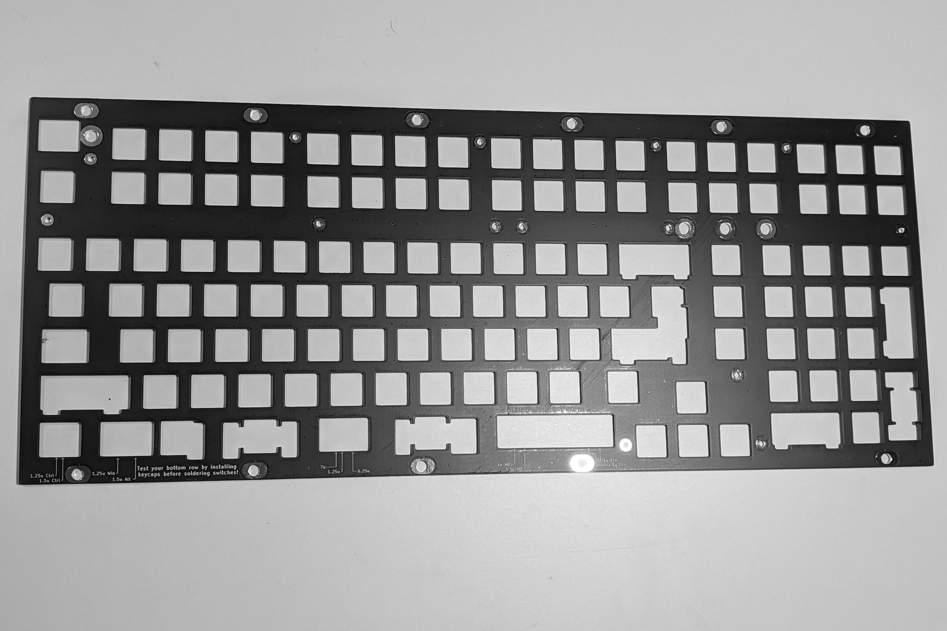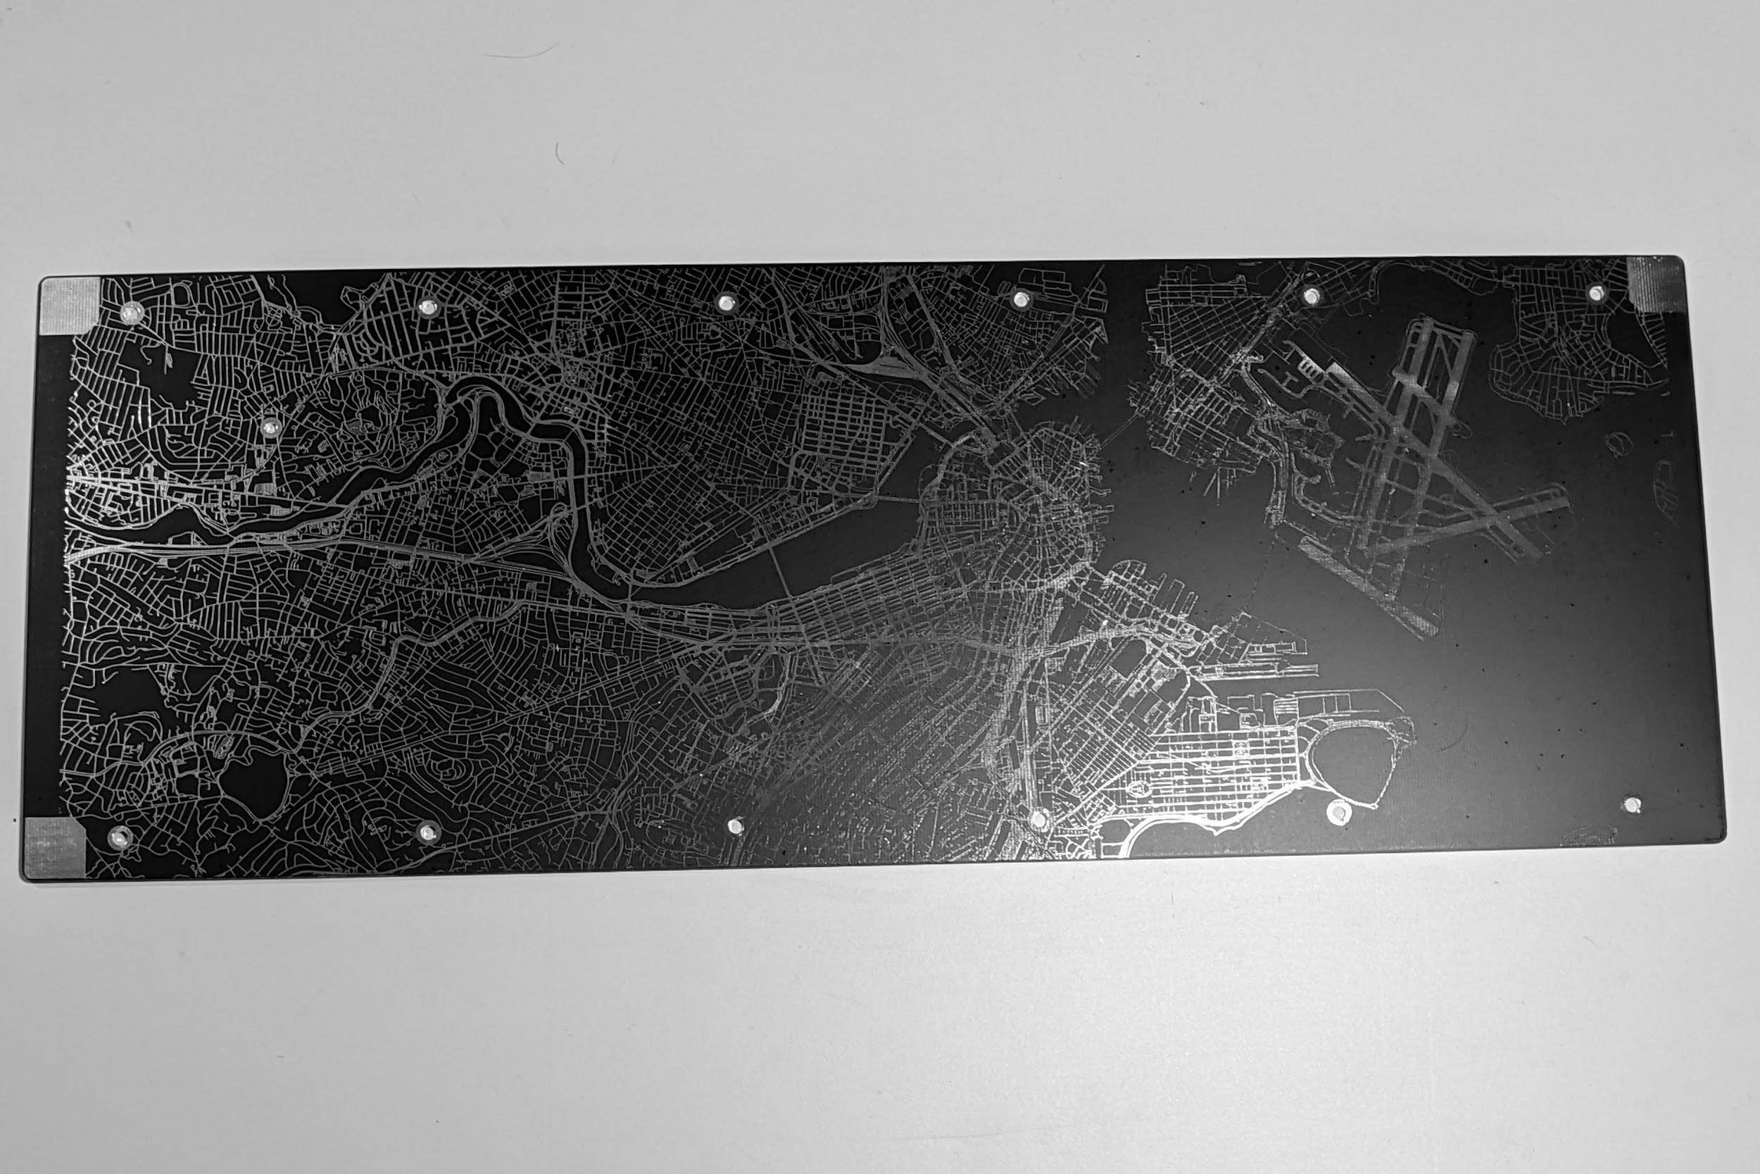

1. 2x FR4 rubber feet holders, and the rubber feet

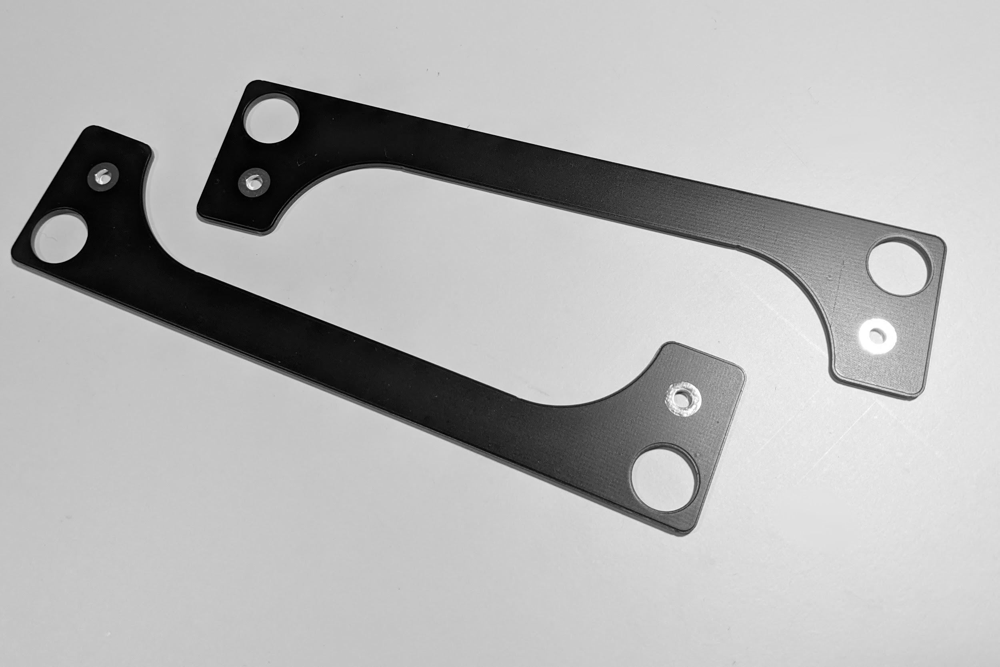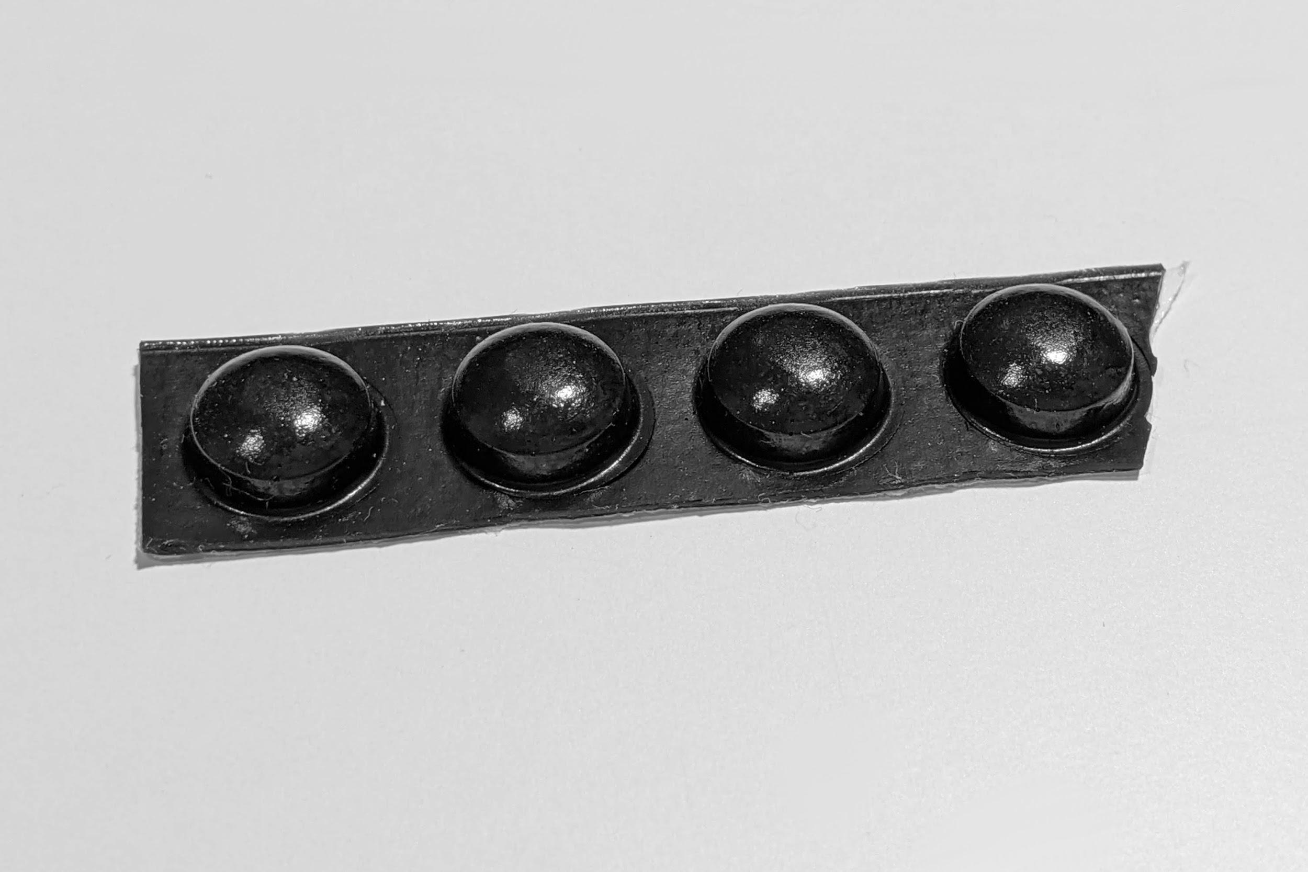

* 3x 3mm LEDs, and 3x 1KΩ resistors:

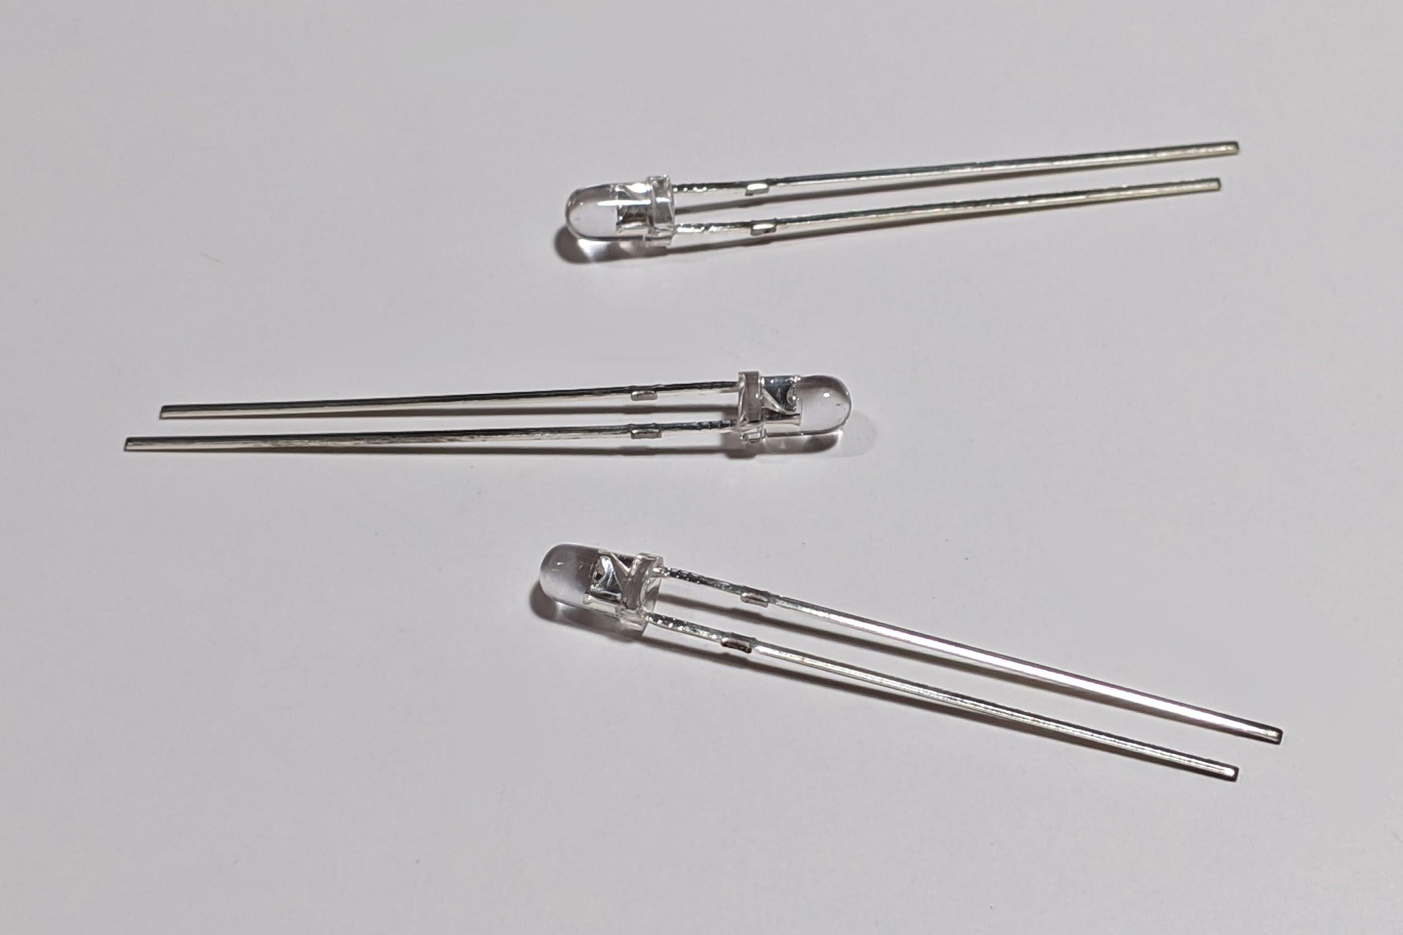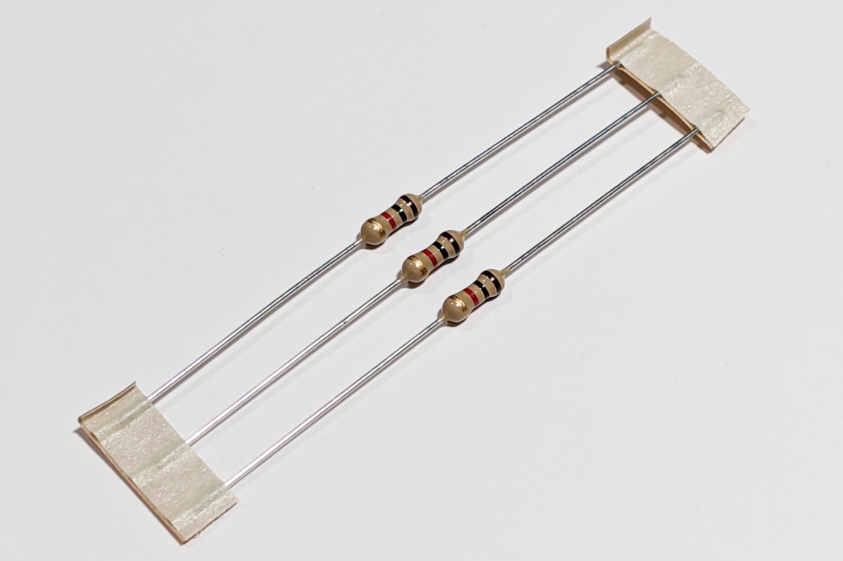

* A rotary encoder (some kits may also include a knob)

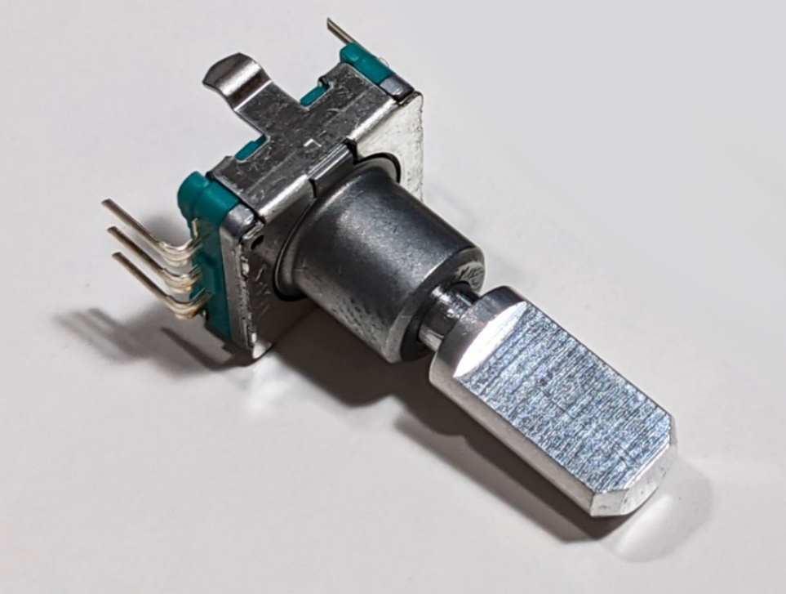

* 15 M3x10mm screws, and 8 M3x6mm screws

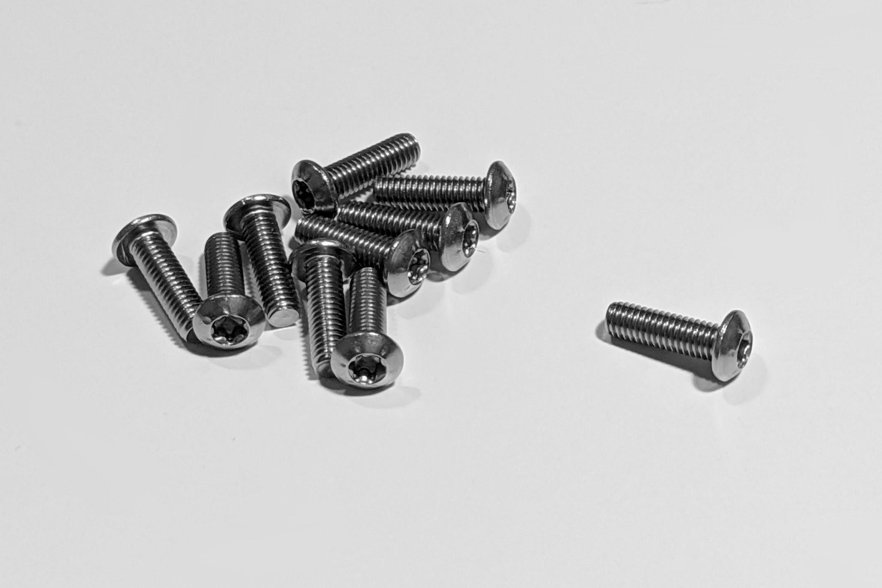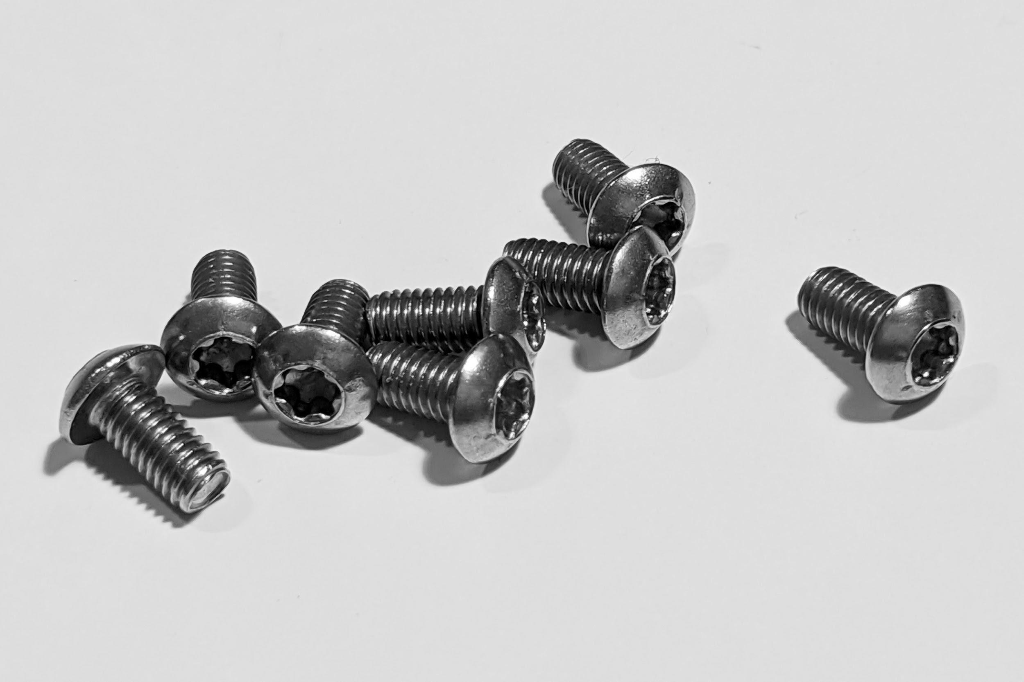

* 11 M3 PEM KF2-M3-ET threaded inserts, and 12 M3 hex nuts

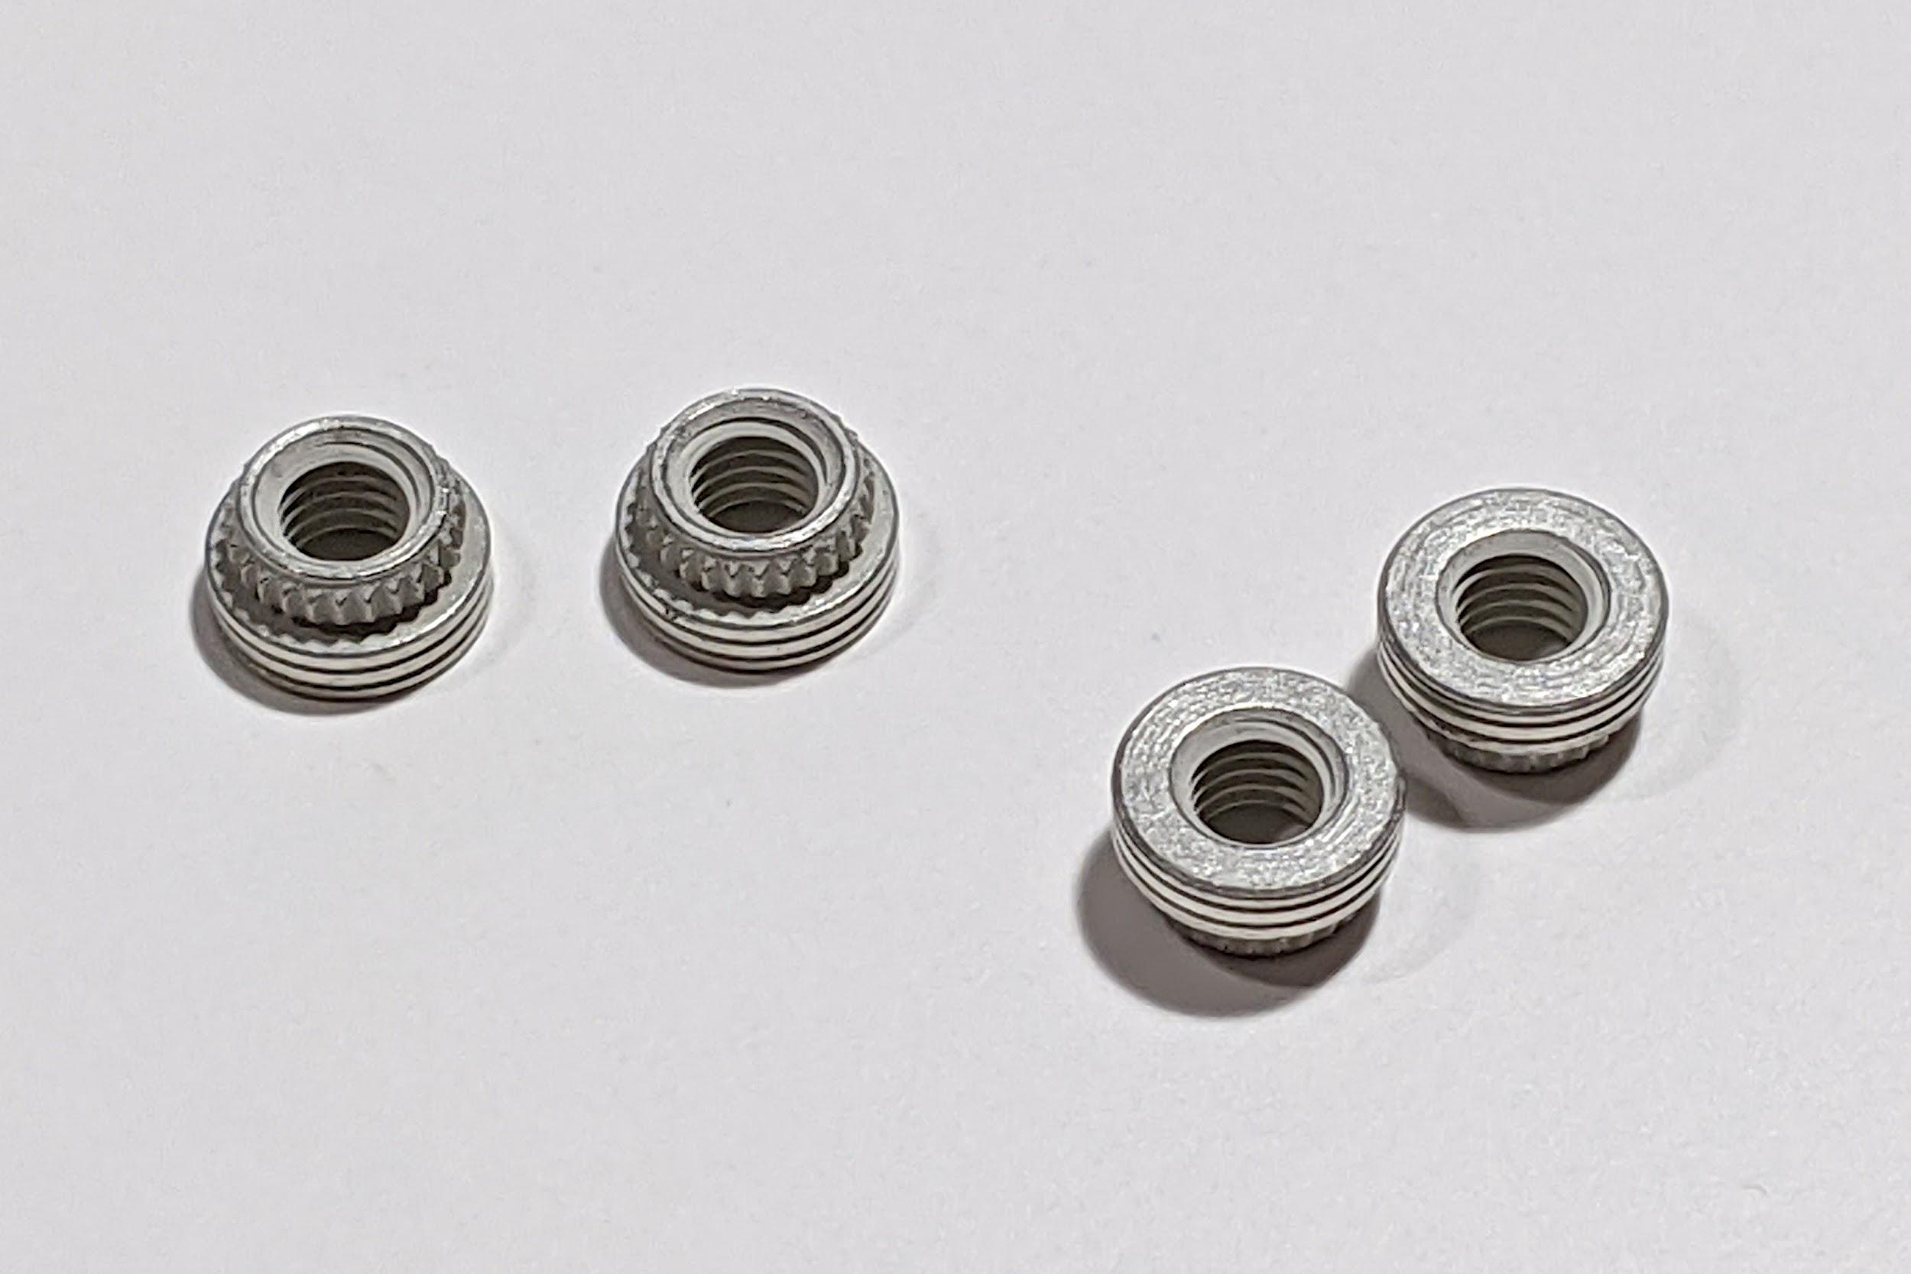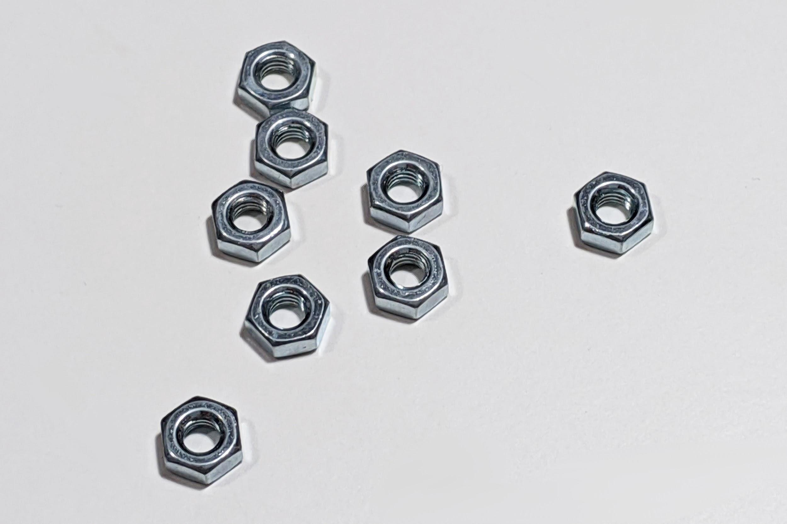

* 14 M2x5mm self-tapping screws

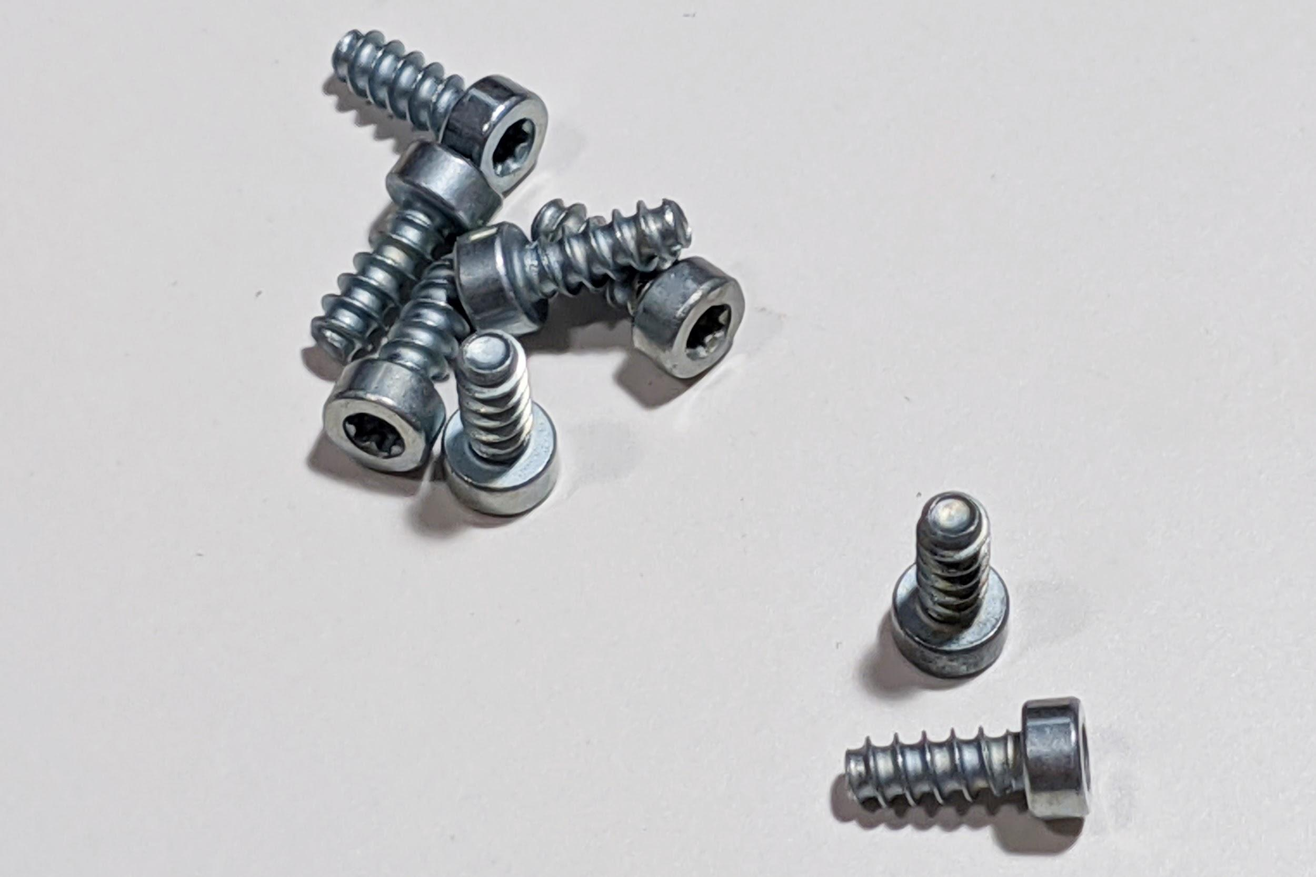

* A reset switch (note on some PCBs this is already soldered on, and won’t be included as a result)

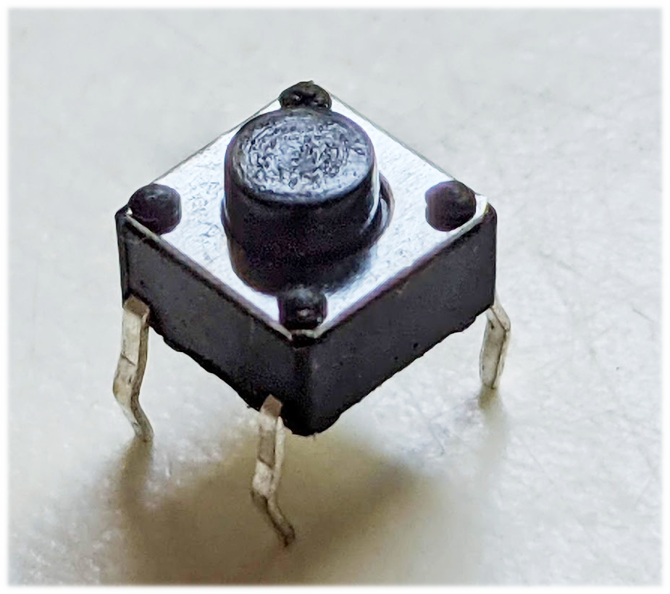

Please inform your vendor if any of the above is missing.

**Parts you’ll need to assemble the keyboard**

* MX-compatible switches. Depending on the layout you choose, you will need between 119 and 127 switches.
* Keycaps of your choice. Make sure that they support your desired layout.
* PCB-mount stabilizers of the correct size and quantity for your preferred layout. PCB screw-in stabilizers are recommended, but PCB snap-in will work.
* A USB-C cable
* A knob. The included encoder has a 6mm diameter D-shaft with a 4.5mm flat. Most knobs meant for 6mm shafts, that either have the flat or use a set screw for mounting, and are smaller than 21mm in diameter, will work.
* (optional) Through-hole LEDs for backlighting. Check that your switches and keycaps support the LEDs you choose - some switches only work with SMD LEDs (which are not supported on this PCB), and others may hit your keycaps.

**Tools you’ll need to assemble the keyboard**

* A 3D printer with a minimum 200mm long x 150mm wide x 210mm tall build area
* A T6 Torx screwdriver or key. Make sure it is actually a T6 size!. A smaller bit may fit in the head, but is much more likely to strip the head.
* A T10 torx screwdriver or key. Likewise, make sure it is actually a T10 size.
* A soldering iron and solder.
* Super glue
* A blue threadlocker, such as Loctite 242, 243, or 248, is recommended to prevent screws from loosening over time.
* If you make mistakes while soldering parts in, you may need a desoldering pump (solder sucker) or desoldering wick to make fixes.

# 

# **Part 1: 3D-printing the case parts**

You will need to 3D-print the following parts. STLs are available on Github [here](https://github.com/bluepylons/Boston/tree/master/Boston - Current design/3D printed version/STLs).

* The 3D-printed case, which comes in 4 pieces: the left half, right half , left-key-separator, and right-key-separator:

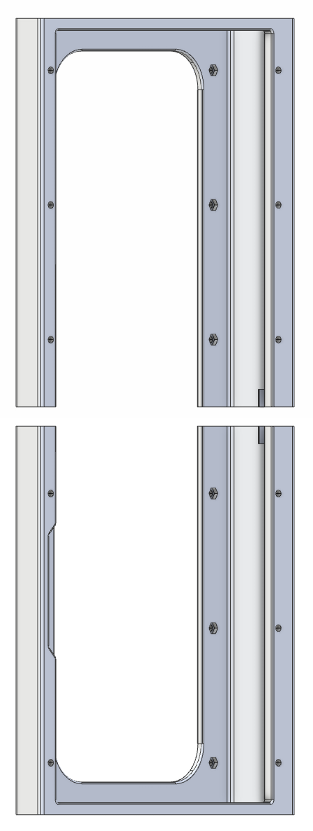

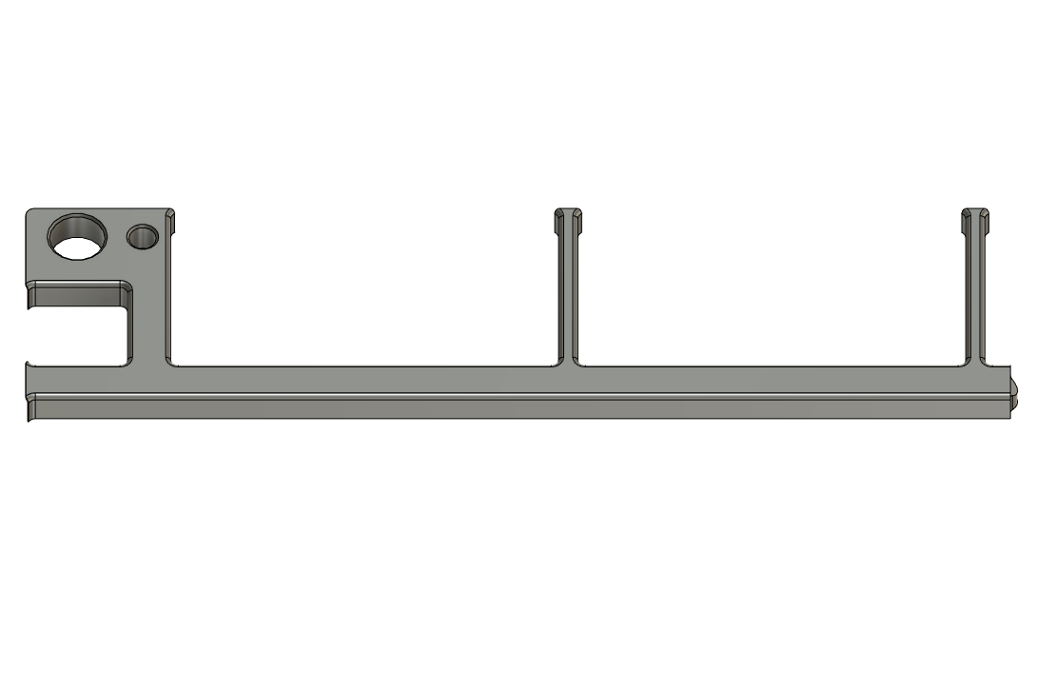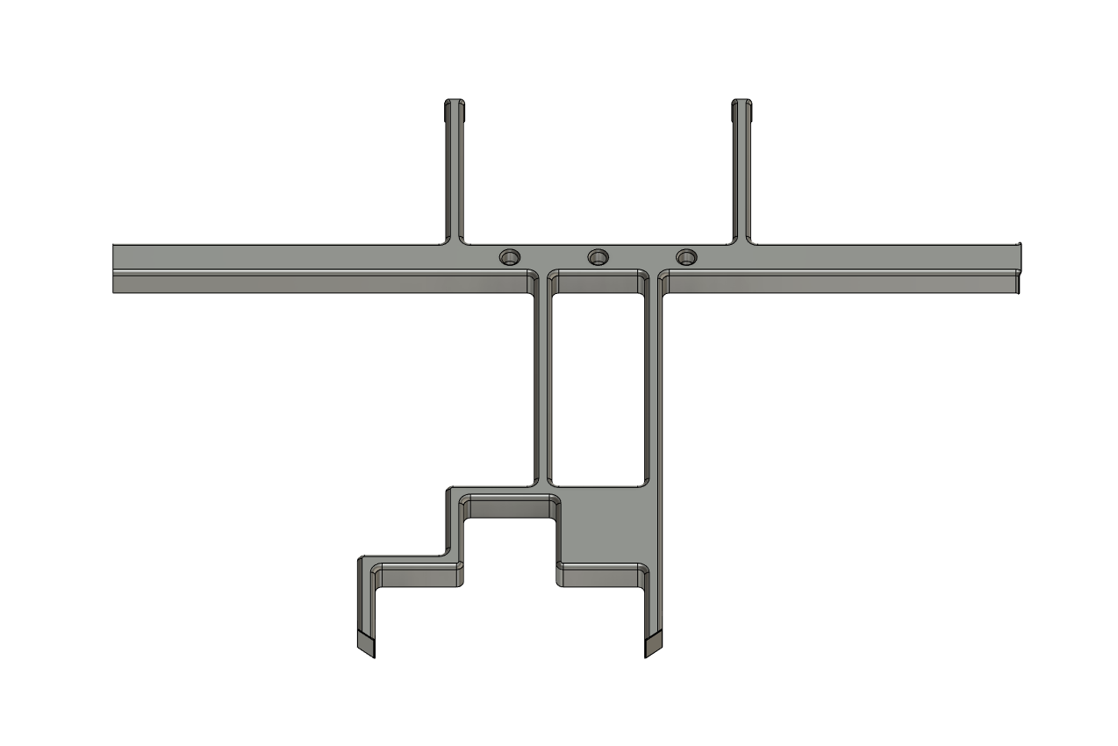

* The 3D-printed spacer for the lock LEDs:

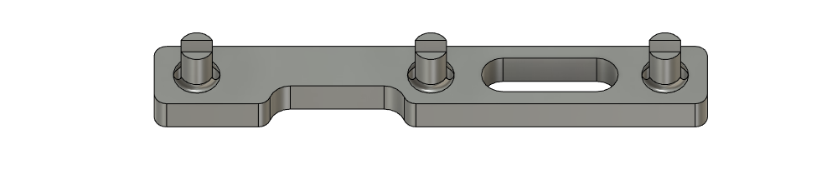

These parts are designed to be printed on standard FDM 3D-printers without needing support material. All prototypes so far have been printed in PLA and PLA+, but other materials (ABS, PETG, etc.) may work.

For the left and right case halves, printing with the long side facing up, like so, is recommended:

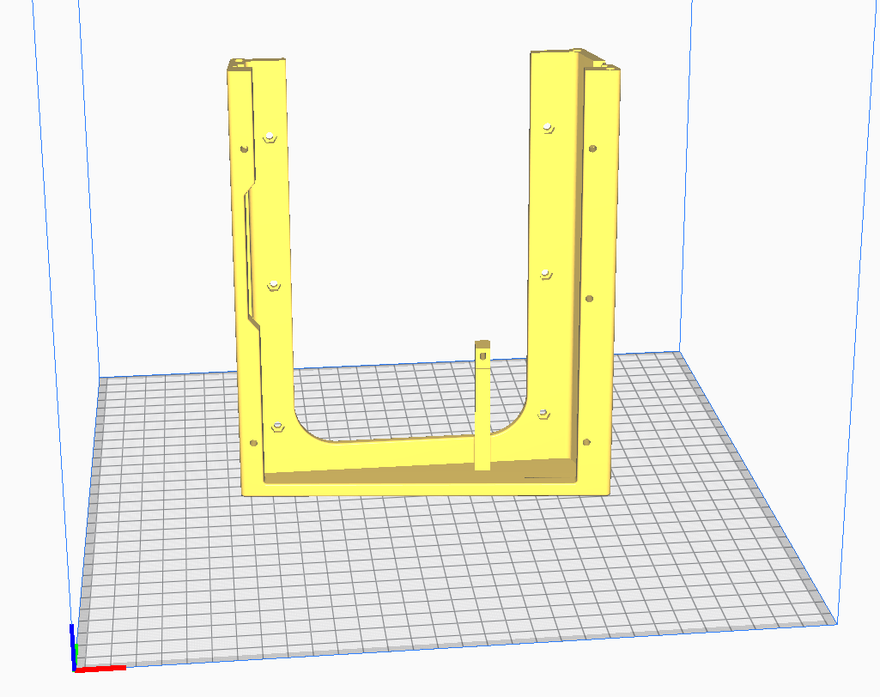

You may also want to adjust the Z-seam setting to prevent seams from being in highly visible places. Generally, you should try to locate the Z-seam at the bottom of the case, preferably in an inside corner.

For the key separators, the following orientation is recommended, with the rounded edges facing up.

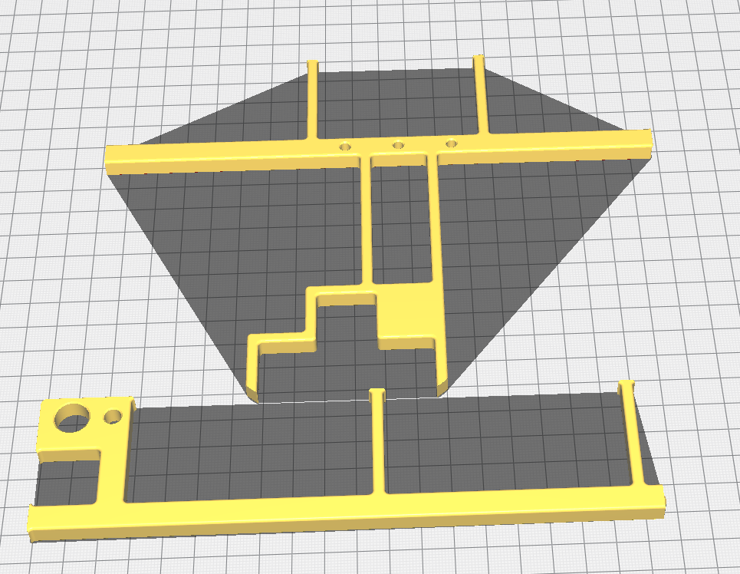

### 

# **Part 2: Putting Together The Plate and Key Separators**

**Soldering the threaded inserts into the plate**

Flip the plate over so that the underside of the plate is facing you. Press in the PEM threaded inserts into the 11 holes on the plate.

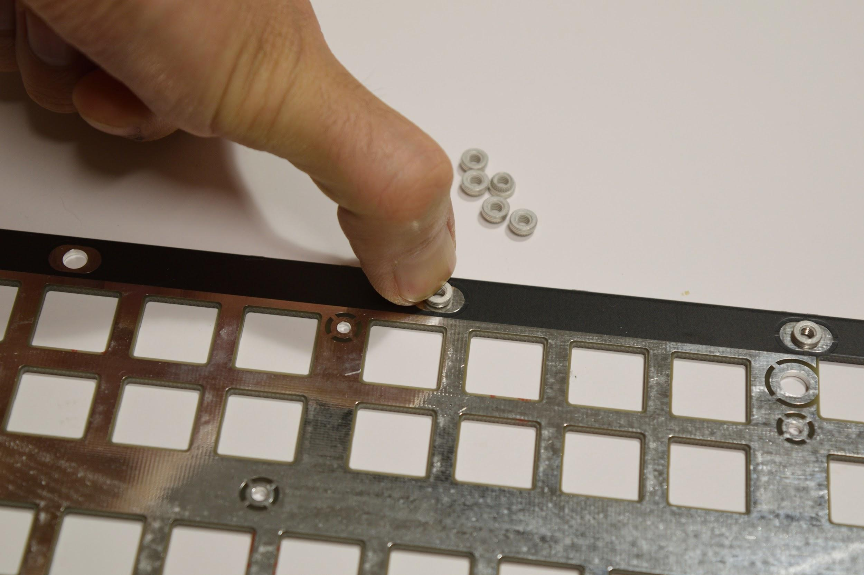If it’s too hard to push the inserts in, you can use one of the M3x6 screws to pull the insert in, using a T10 Torx screwdriver. Remove the screw when the insert is all the way in.

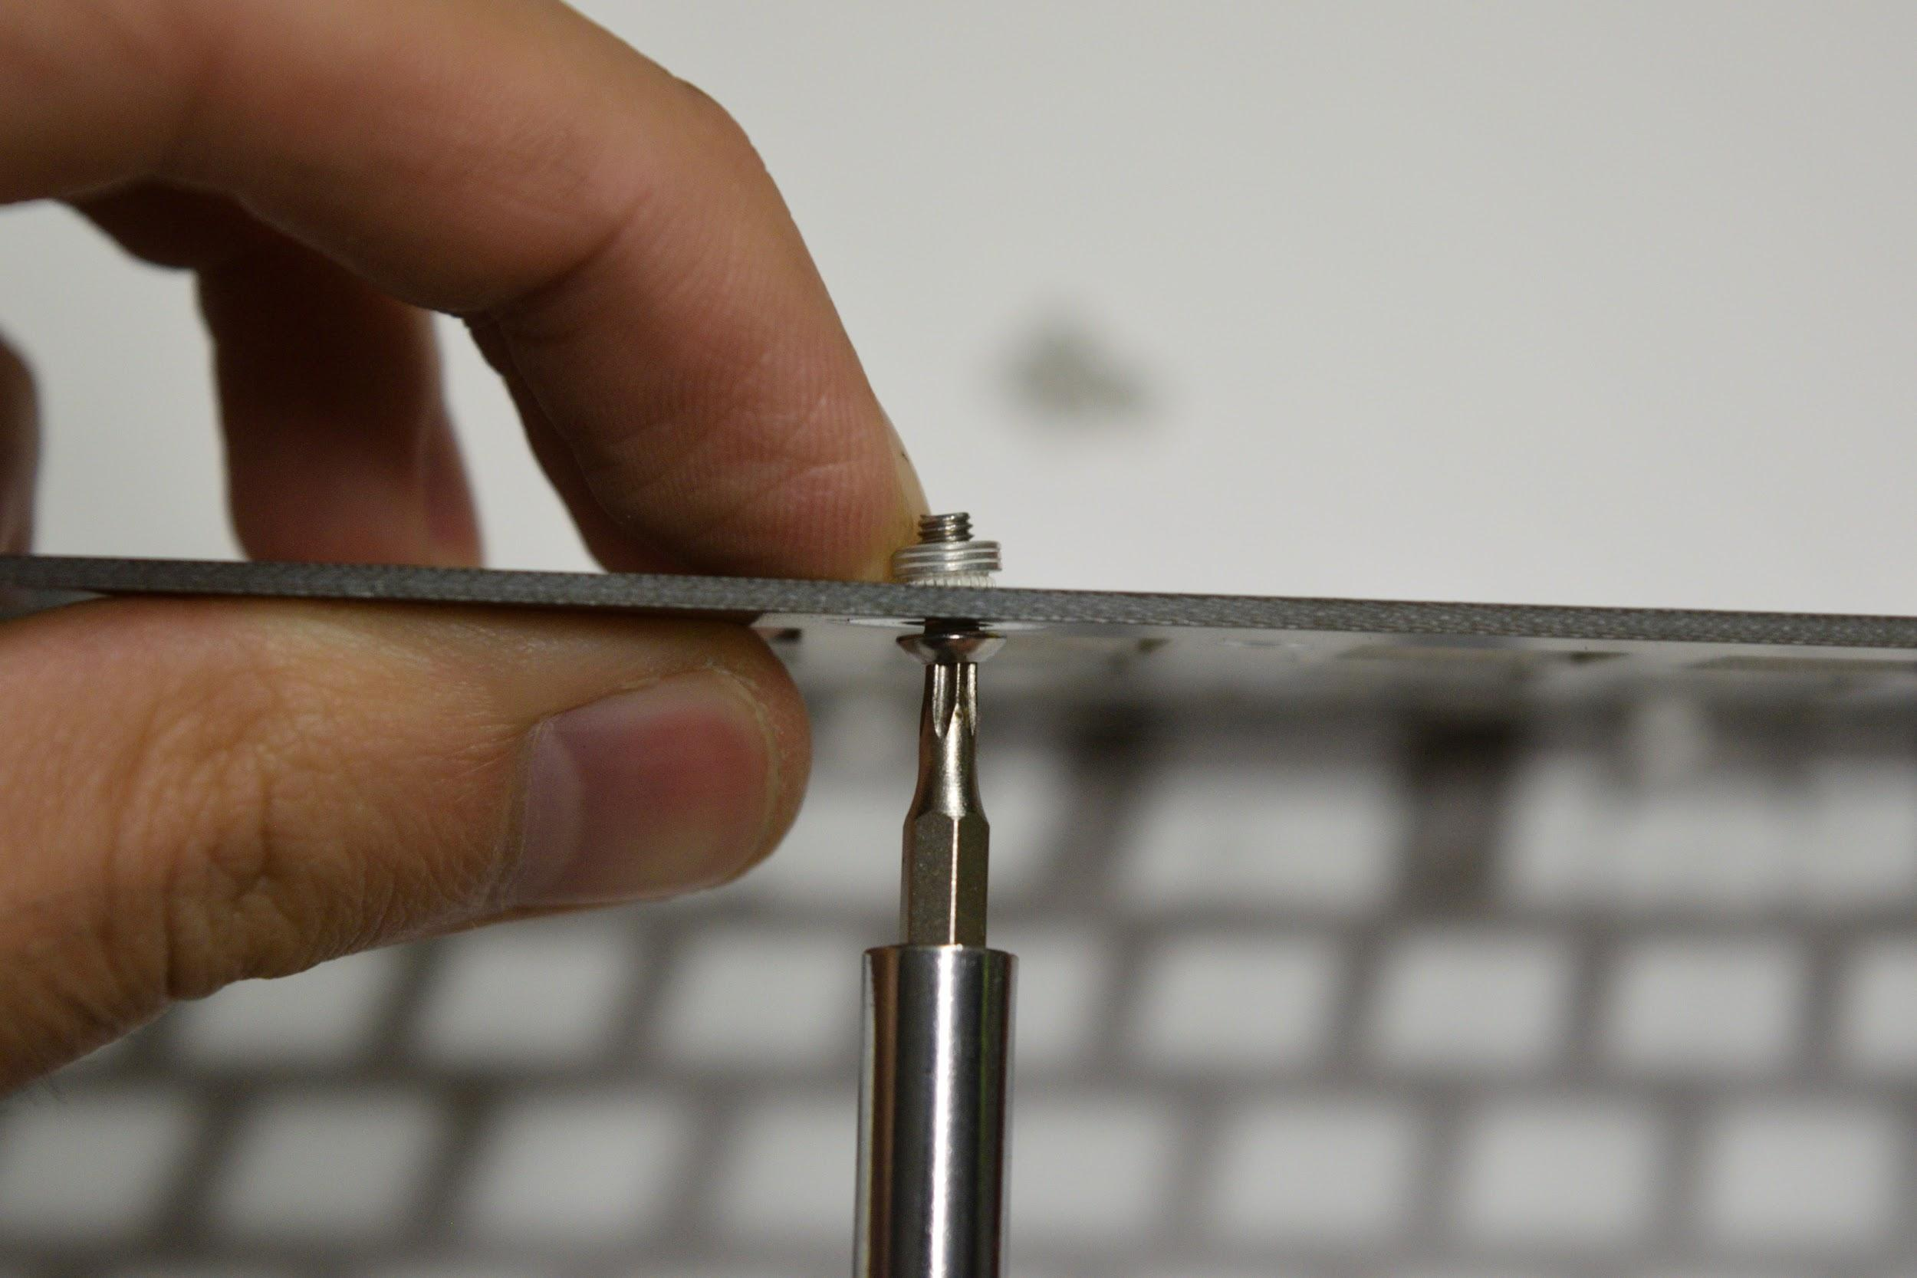

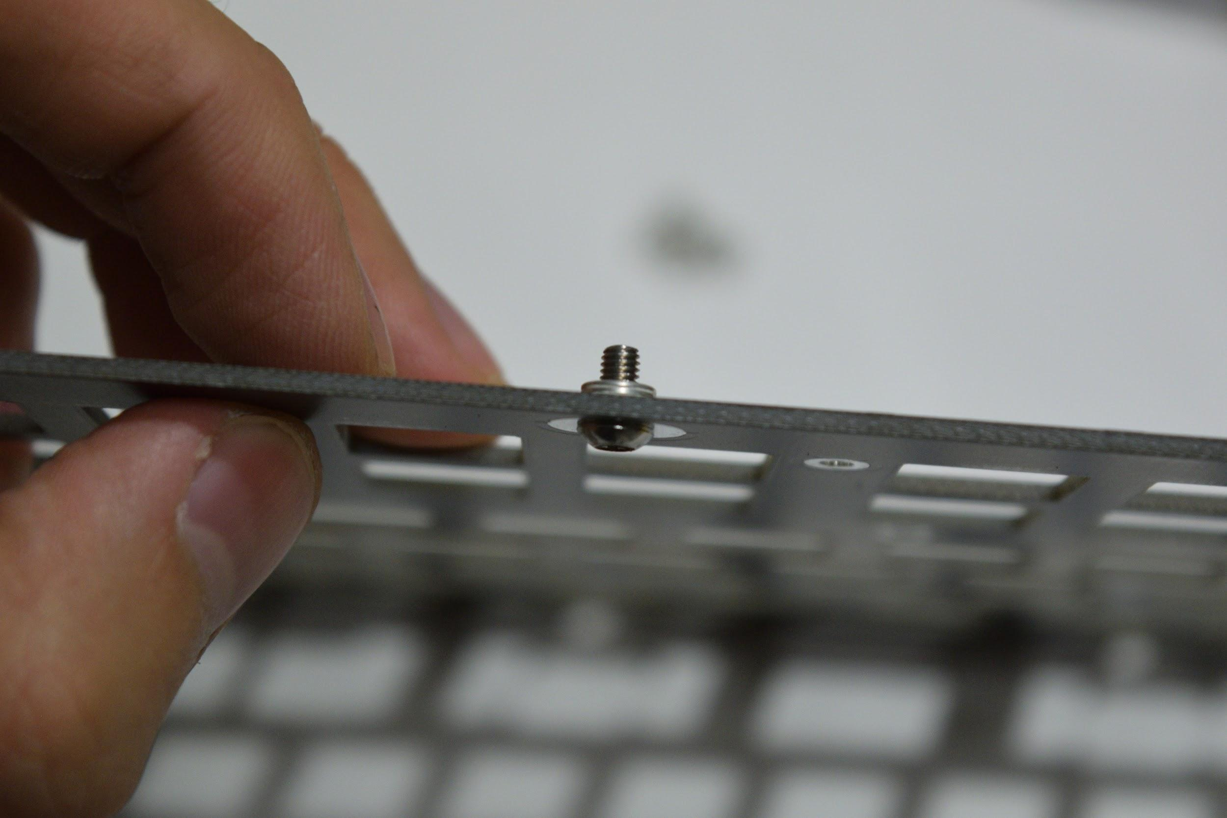

With the inserts pushed in, double check that they’re on the correct side - they should be on the bottom of the plate, not the top. Also, make sure the inserts are all of the way in and fully seated. Then solder, them in place:

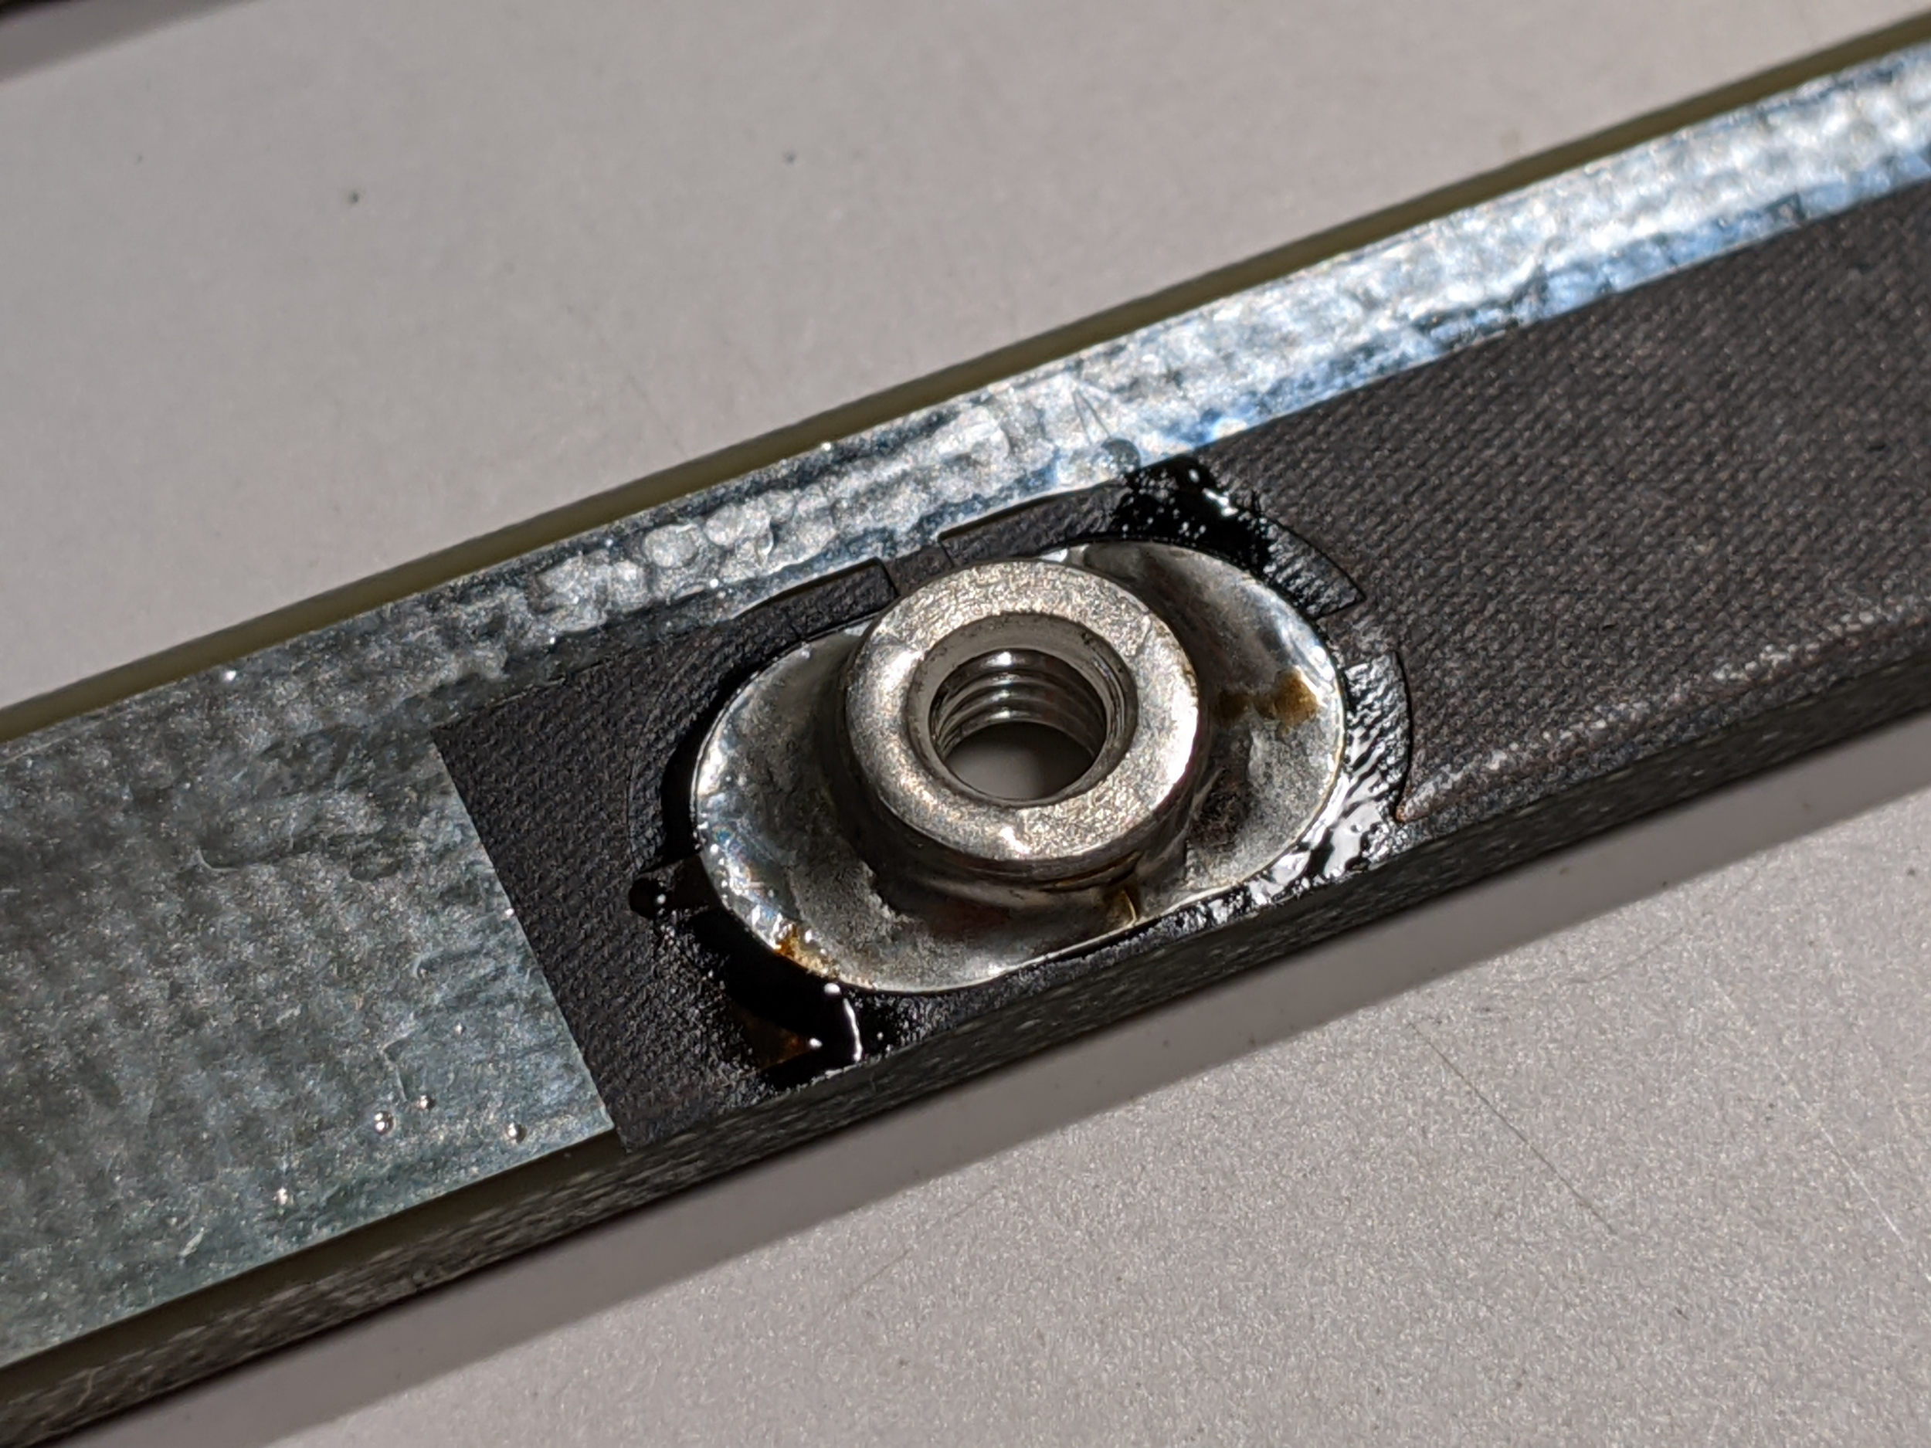

It may take some time for your soldering iron to get the nut and plate hot enough to get the solder to flow well. Also, avoid getting solder on the threads. If you get solder on the threads, try running an M3 screw through to clear solder off the threads. If that doesn’t work, you’ll need an M3 tap to remove the solder from the threads.

**Attaching and aligning the key separators**

The key separators cannot be adjusted after the switches are soldered on without desoldering all your switches (unless you are using a V0.7 or newer PCB). Make sure you get this right before soldering anything!

Next, grab the 3D-printed left-key-separator and right-key-separator pieces, and the M2x5 self-tapping screws.. These pieces need to attach to the plate before the switches are soldered in.  
  
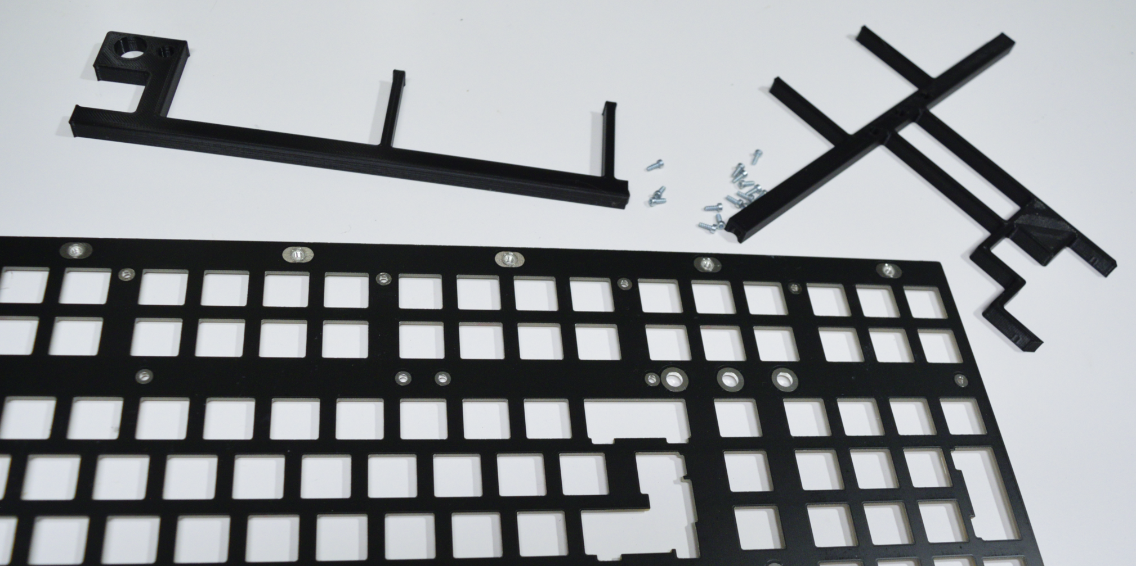

Attach the key separators to the plate using the M2x5 self-tapping screws, via the small holes located in the plate. Use a T6 Torx screwdriver for this. Make sure the screws go in straight! **Do not tighten these all the way - leave them about a ½ turn loose, since we’ll need to adjust and align these in a little bit.** There are 14 screws that need to be attached in total - 6 on the left separator, and 8 on the right separator.

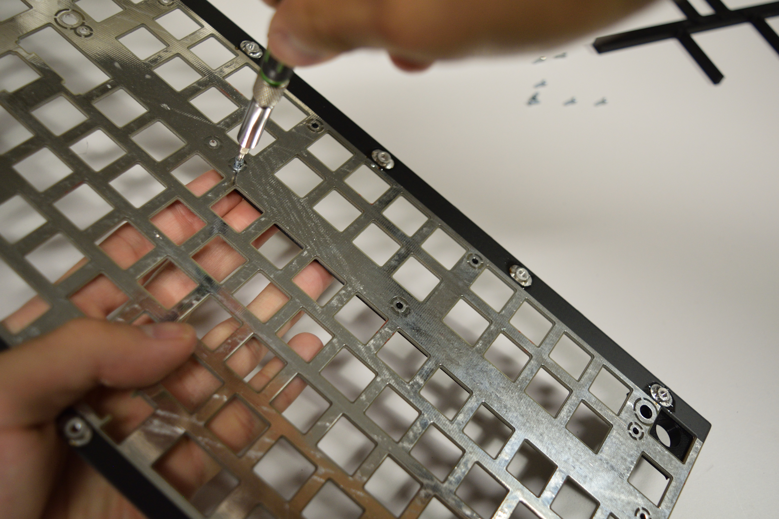  
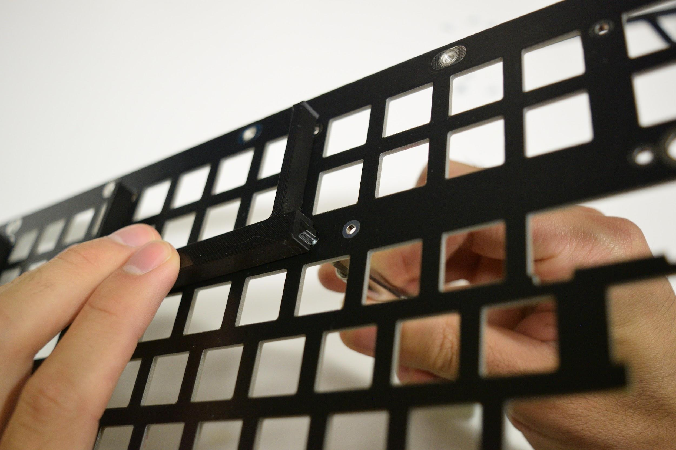

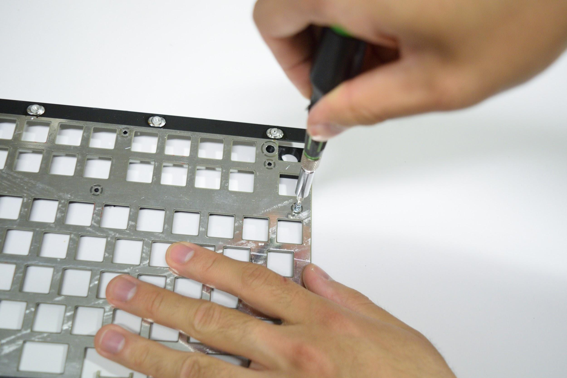

With the screws in but not tightened fully, do a test fit against the left and right case halves by sliding the plate into the left and right case halves. Note that you’ll have to slightly spread apart the right case half to get it past the arrow key cluster.

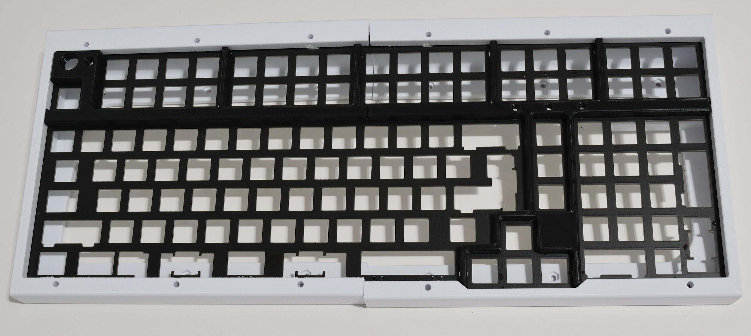

Attach the plate to the case using M3x10mm screws. Make sure the plate is fully seated against the case.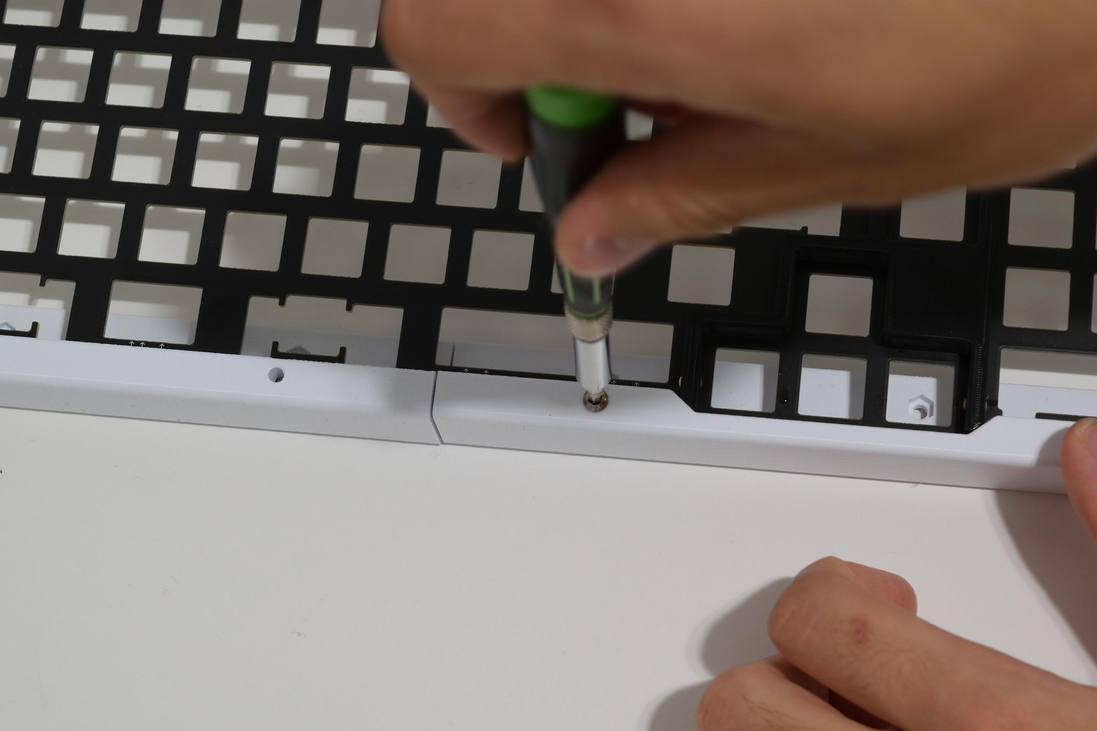

Adjust the separator pieces so that the gaps between the separators and the case halves (marked in orange) are minimal when the plate is slid into the very end of the case halves. There may be a small gap between the two separators (gap marked in pink) - this is normal.

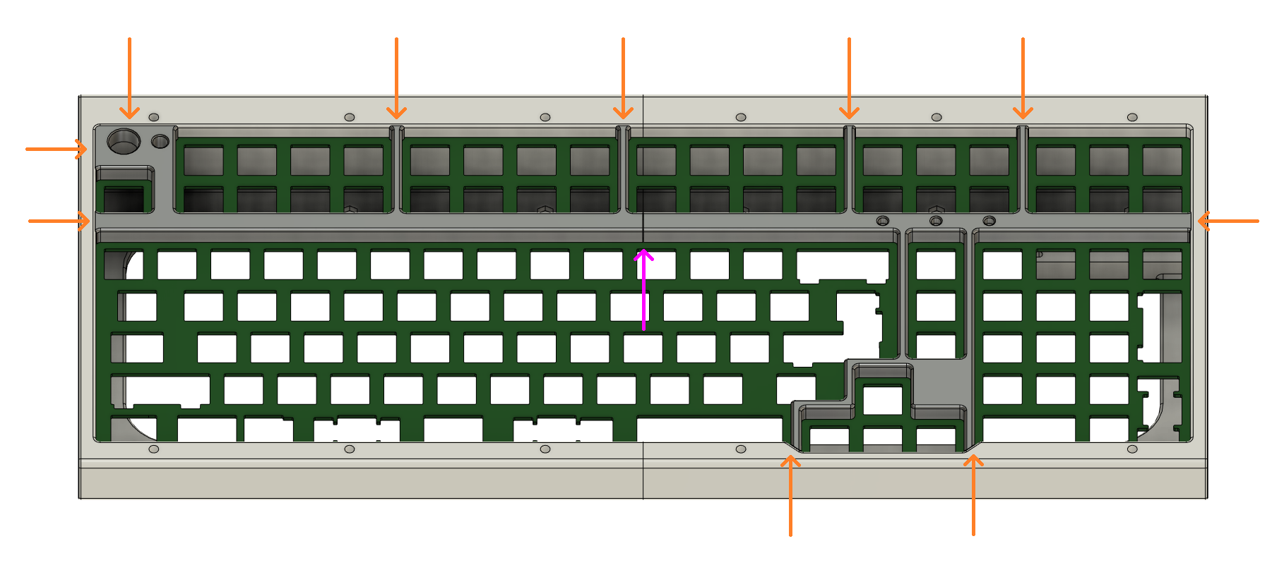  
Flip the assembly over, and tighten the screws that can be accessed:

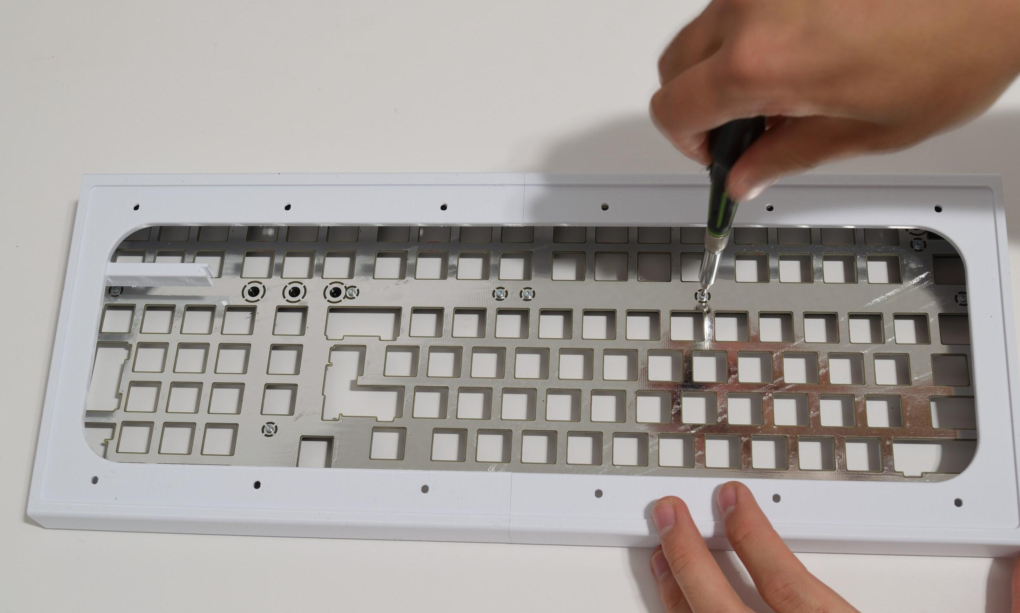  
  
Remove the case halves, and tighten up the remaining screws:

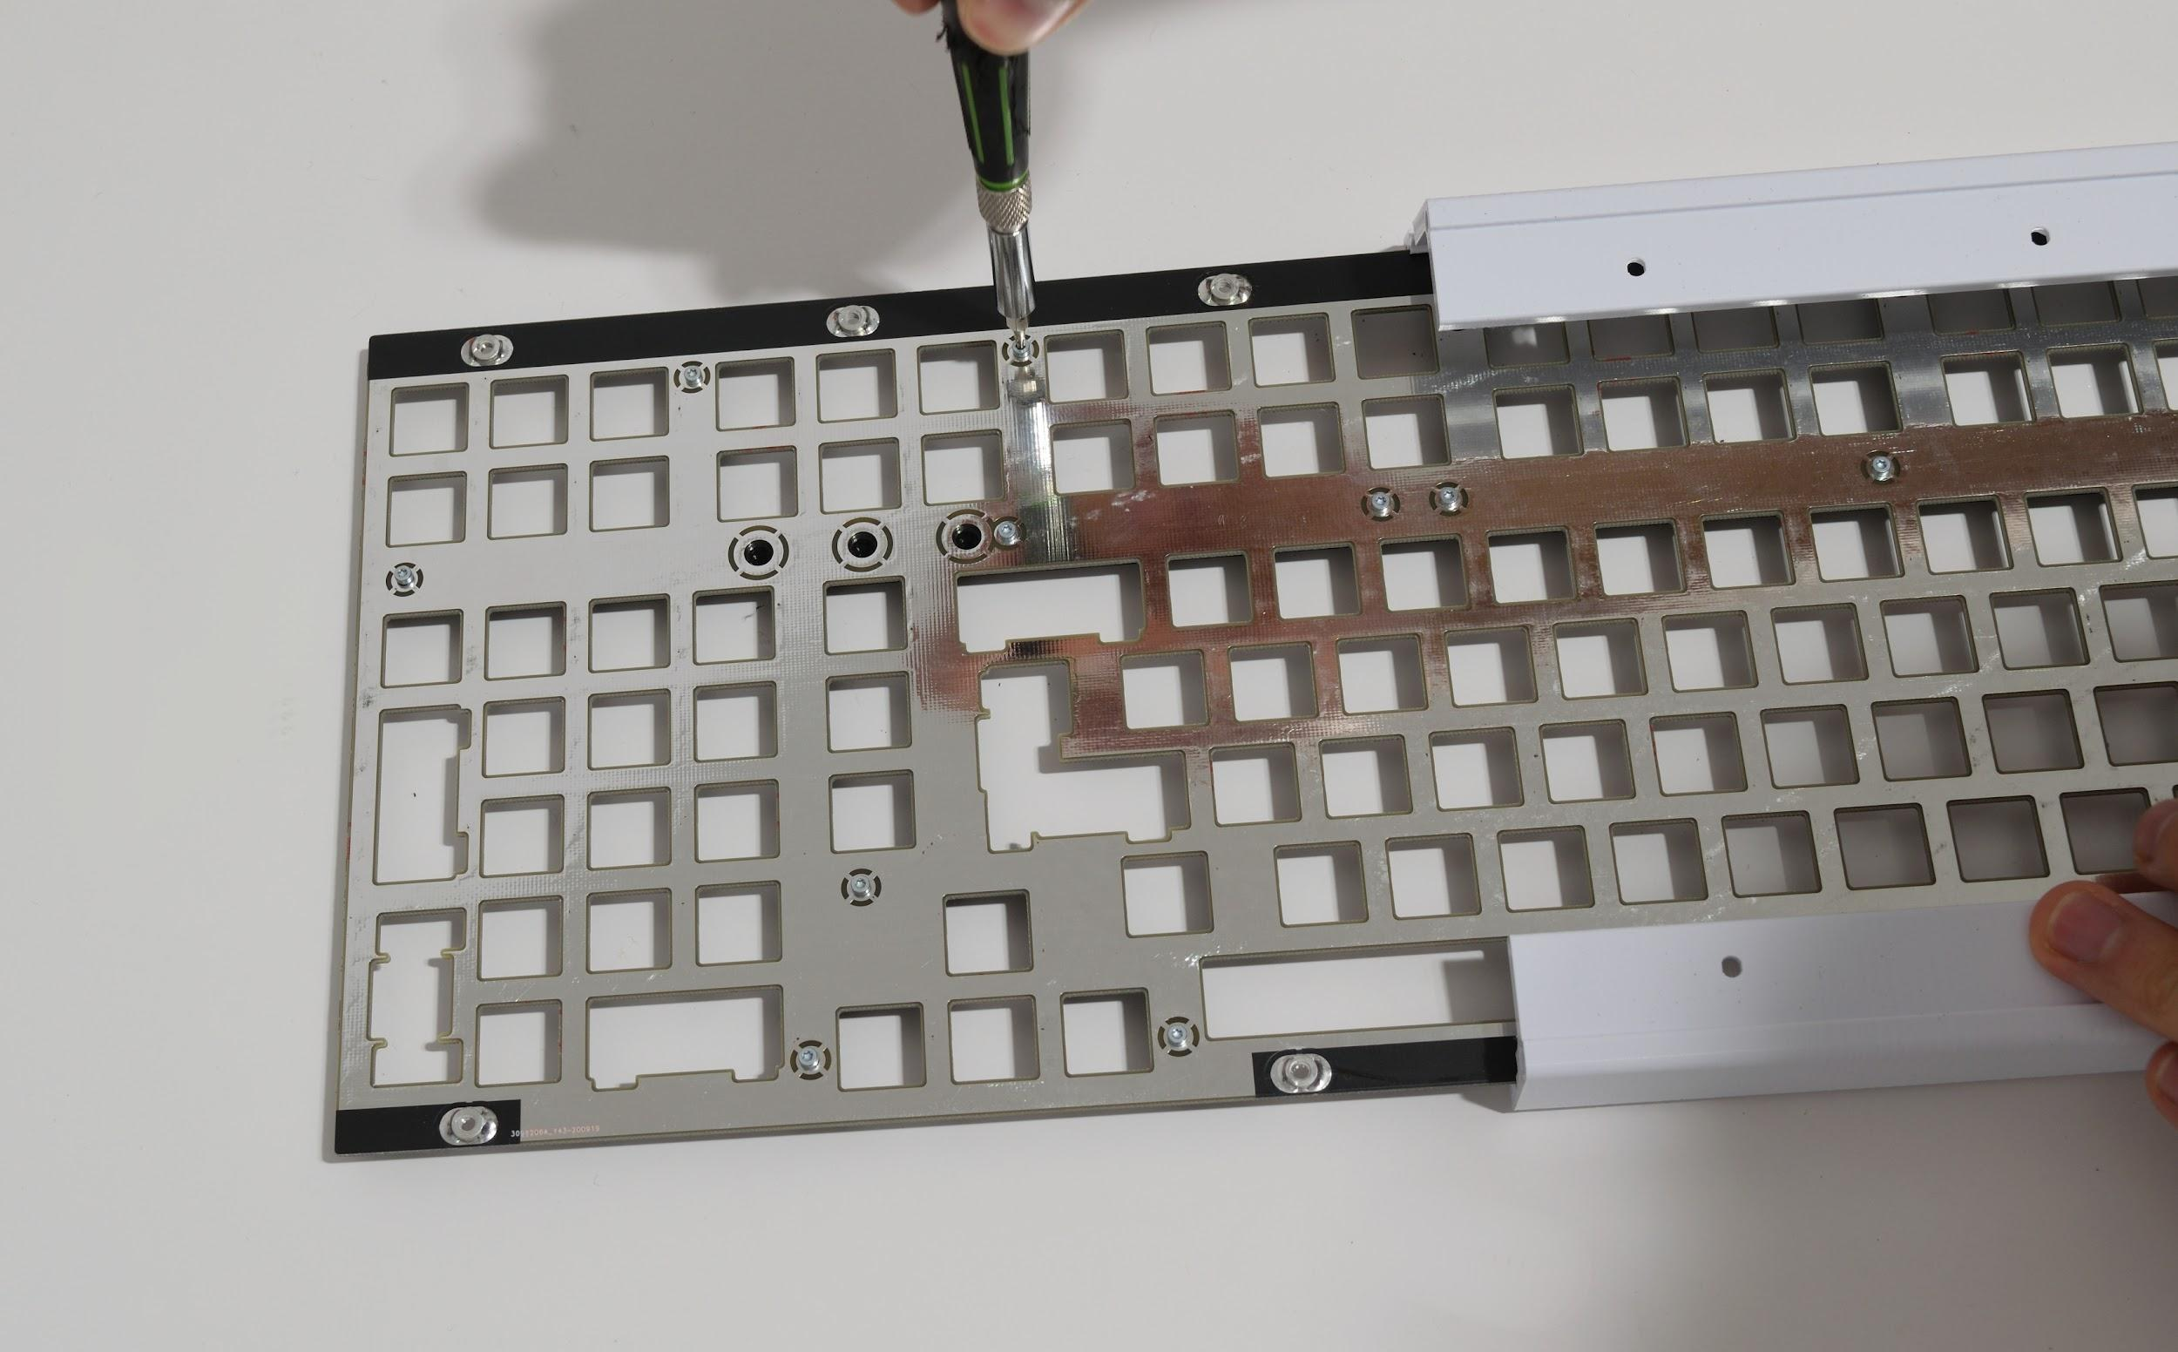Put everything back together and do a final check of the gaps. Make any adjustments as necessary. Remember - you can’t fix this once the switches are soldered in! (unless you are using PCB V0.7 or newer)  
  
When everything looks good, remove the case halves again, and make sure all the screws are tight.

# **Part 3: Testing and Soldering Additional Parts on the PCB**

**Testing each key the PCB**

While PCBs have been tested before being shipped, there is a small possibility of damage from shipping. Testing the PCB before further assembly is recommended - use a tweezer, metal keycap puller, wire, or unbent paperclip to short the switch opening pins, and a program such as [Aquakeytest](https://geekhack.org/index.php?topic=34670.0) to ensure that each key works.   
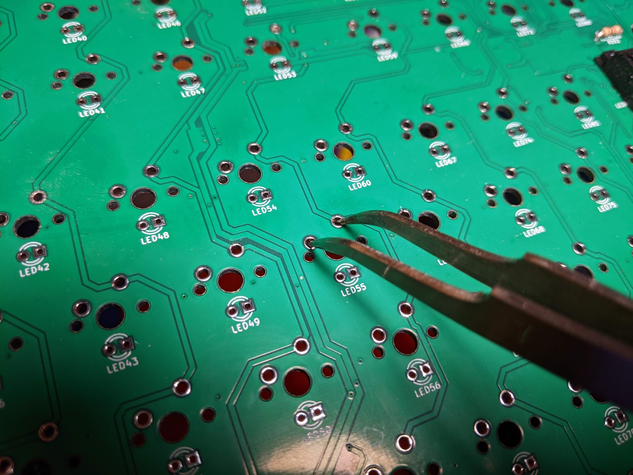  
 **Soldering on the 1KΩ resistors**

Grab the 3 1KΩ resistors and solder them into the spots for R200, R201, and R202, on the top side of the PCB. If you’re using your own LEDs and want them brighter or dimmer, you may want to use different resistors than the provided resistors.

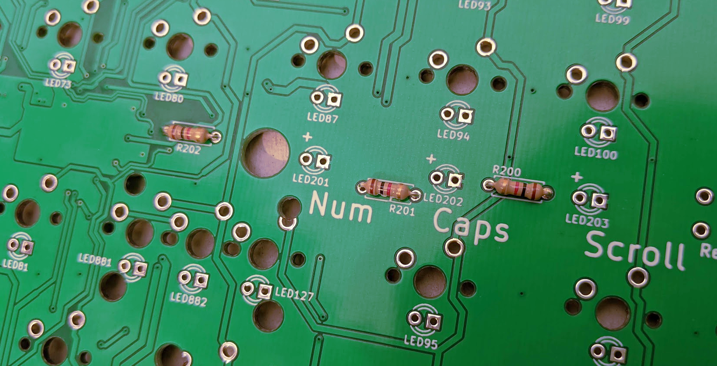

**Soldering on the lock LEDs**  
Grab the spacer for the LEDs, and run the LEDs legs through it. Place the LEDs and spacers onto the PCB, for spots LED201, LED202, and LED203. Note that the spacer only fits in one way.

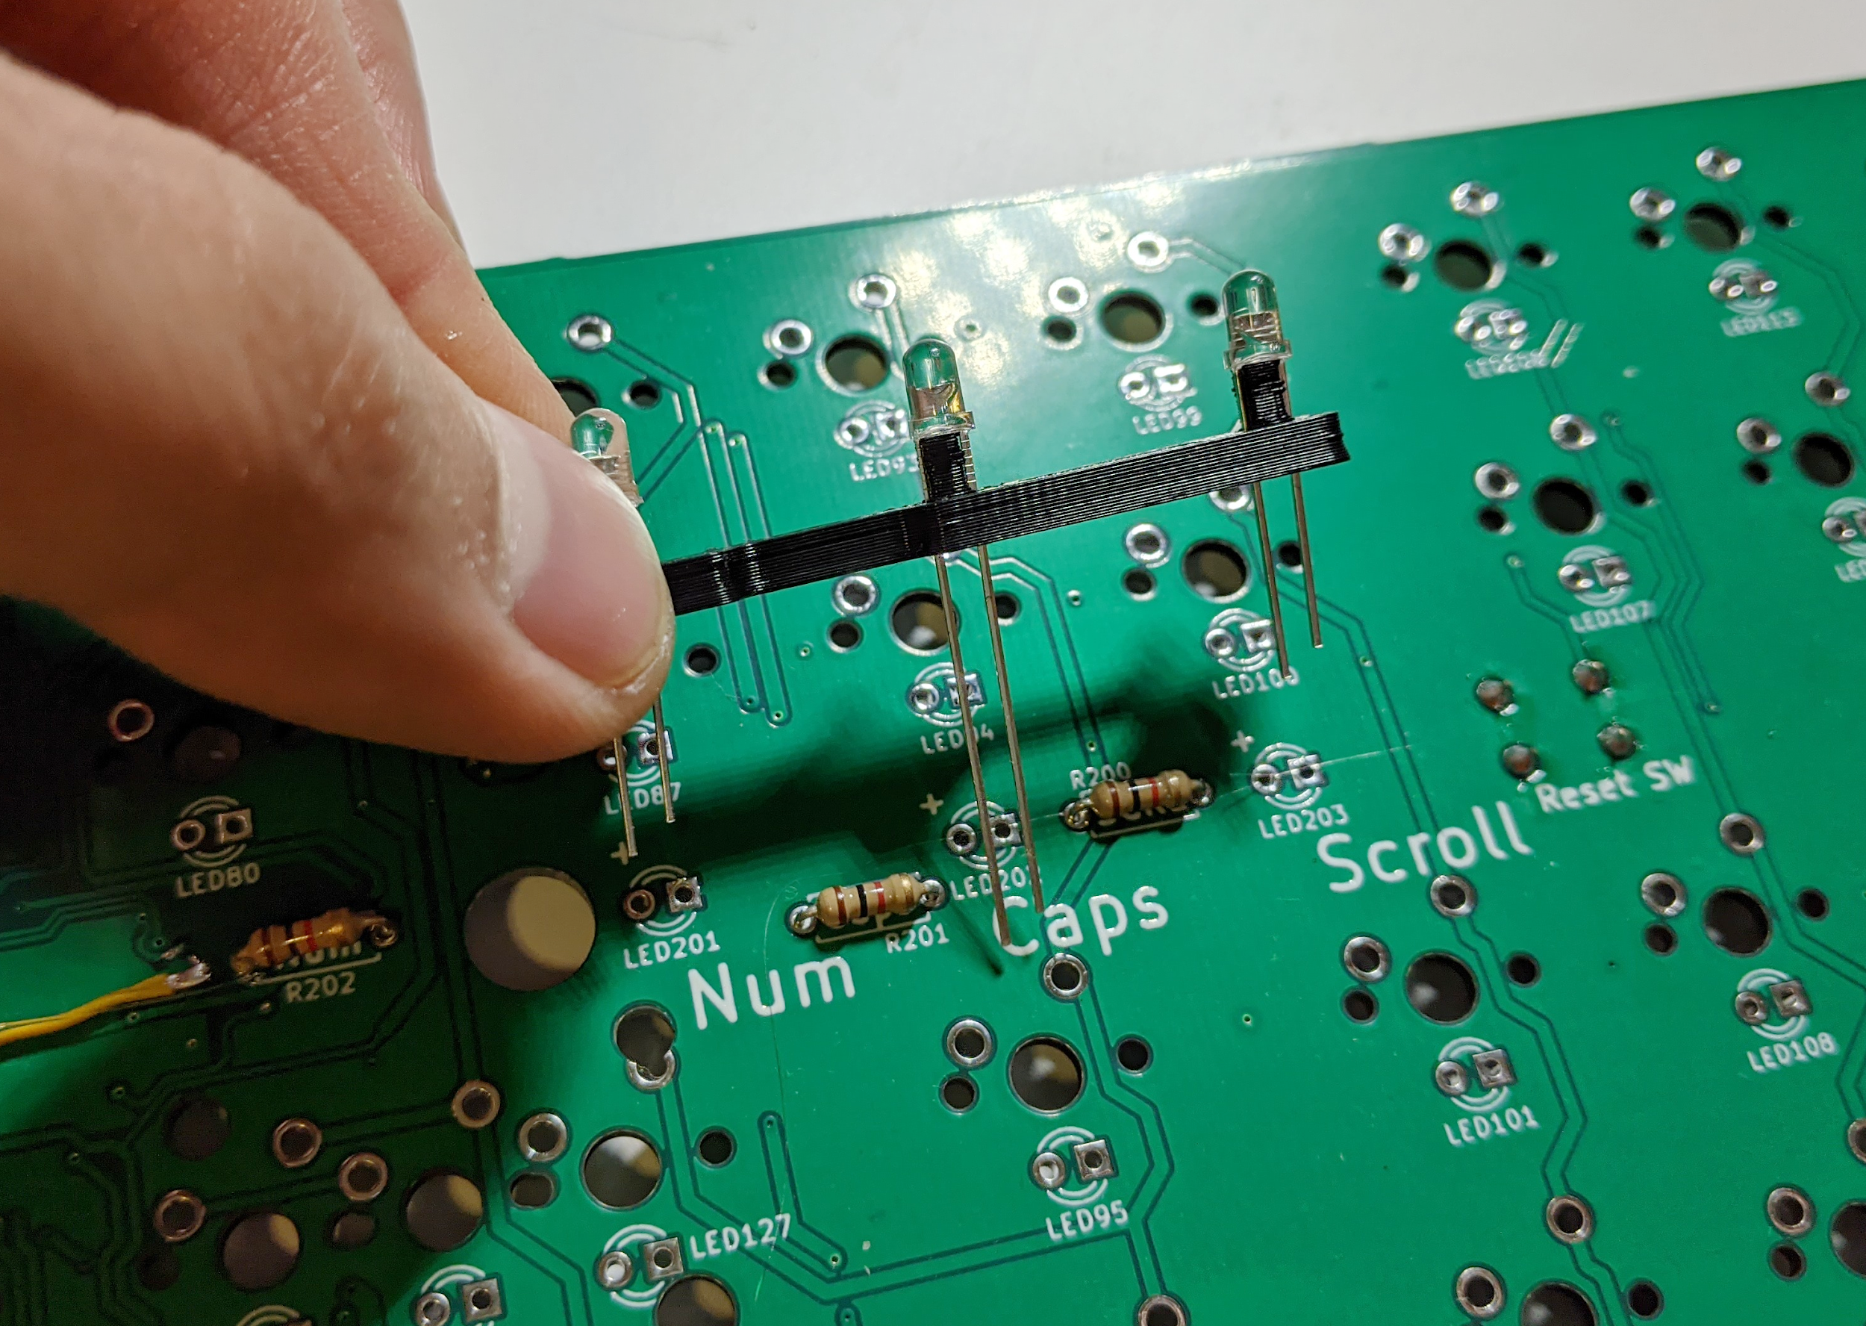

Note that LEDs are directional and will not light up if soldered in backwards. The longer leg on an LED is +. Make sure this matches up with the + symbols on the PCBs.

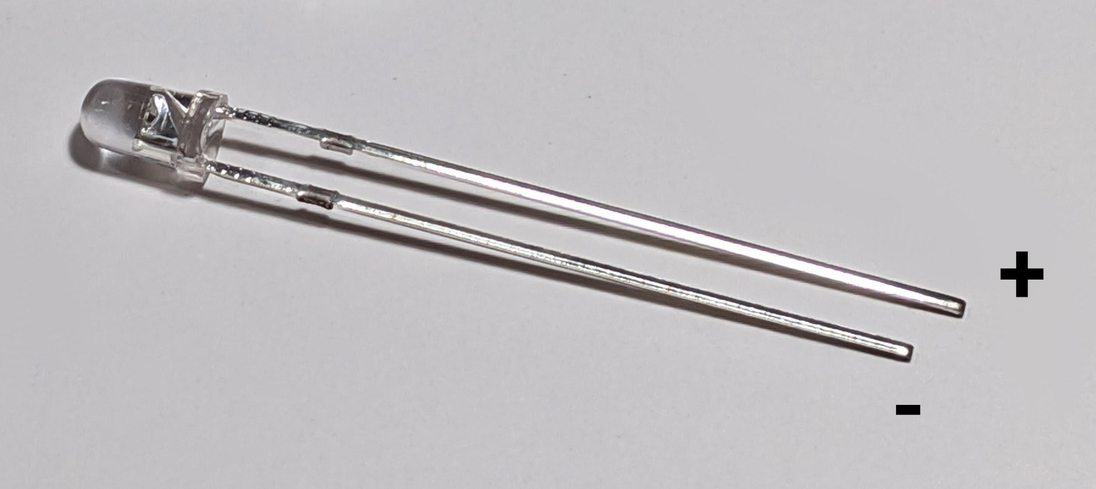Once the LEDs are in, solder them in. Make sure that they’re in straight!   
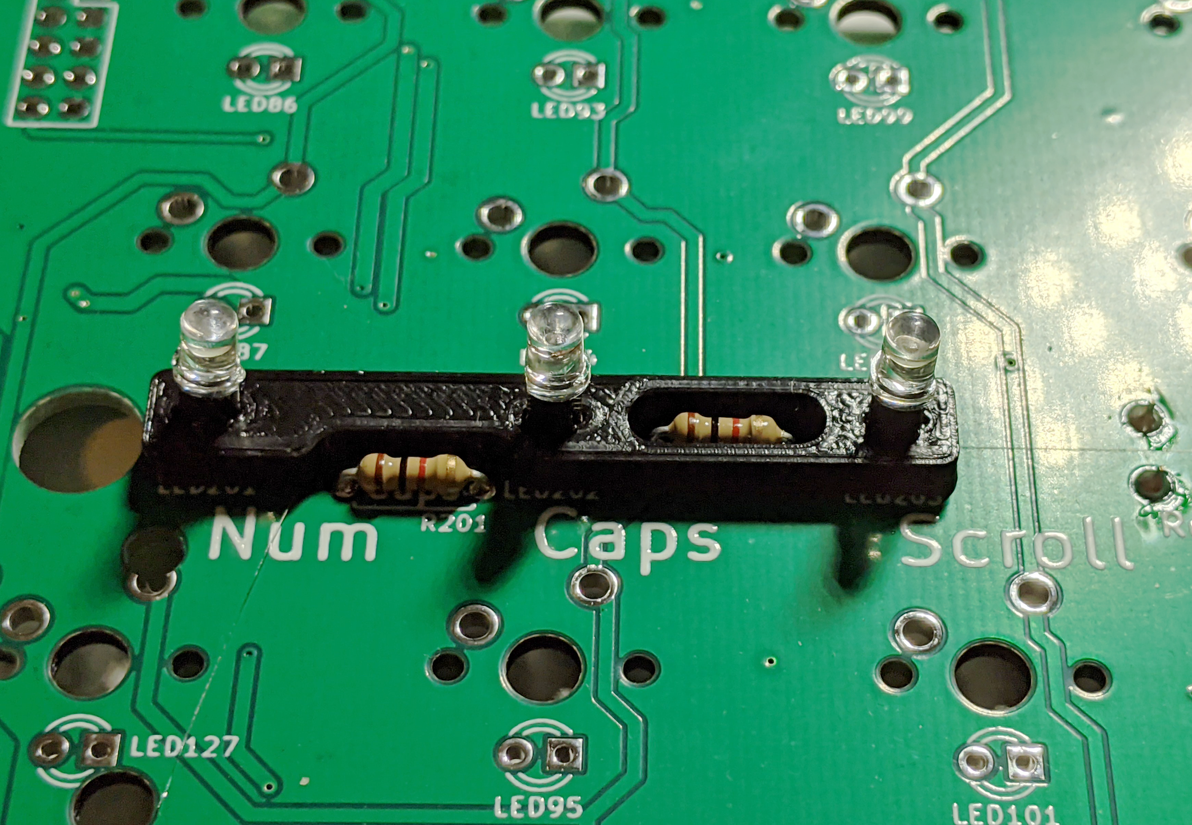

If you haven’t already done so, clip the legs on the resistors and LEDs with a pair of flush cutters.

**Soldering the rotary encoder onto the PCB**

Next, solder on the rotary encoder onto the top left corner of the PCB.  
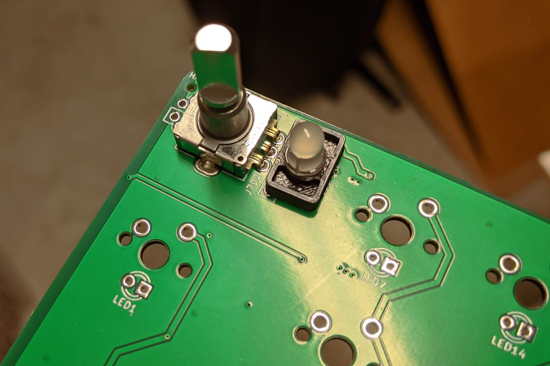

**Soldering on the reset switch**If your PCB did not come with the reset switch soldered on, solder it onto the bottom of the PCB. It’s goes right above the numpad:  
  
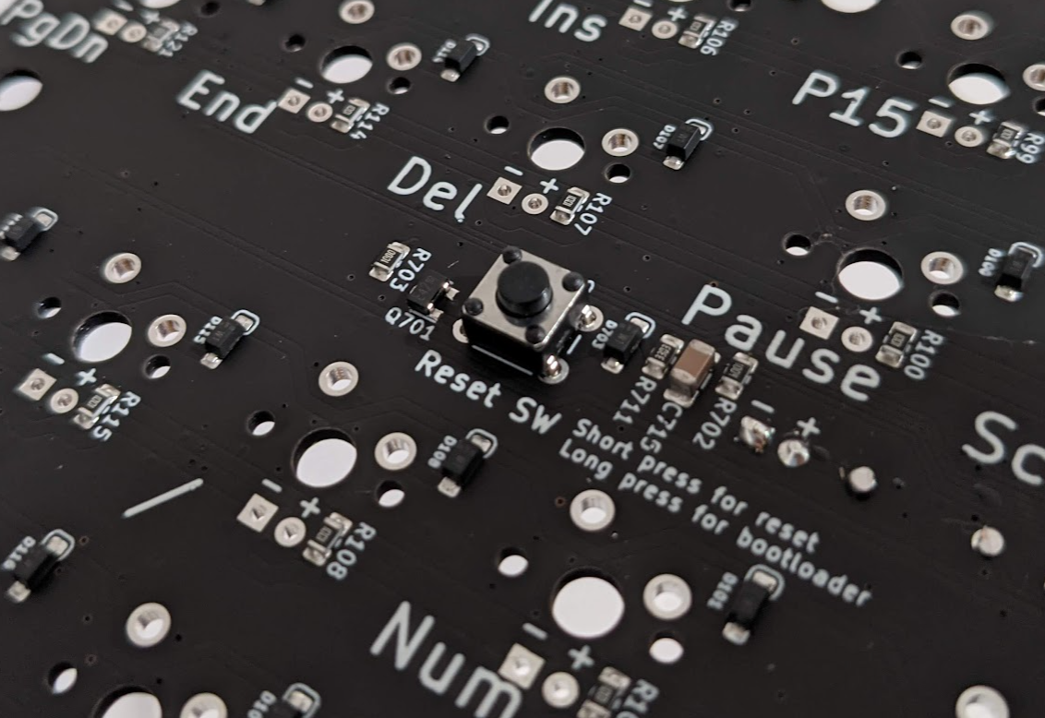

**Soldering on the spring-loaded pins**

If you are using PCB V0.7 or newer, solder on the spring-loaded pins, which are soldered to the top side of the PCB on the right side of the keyboard.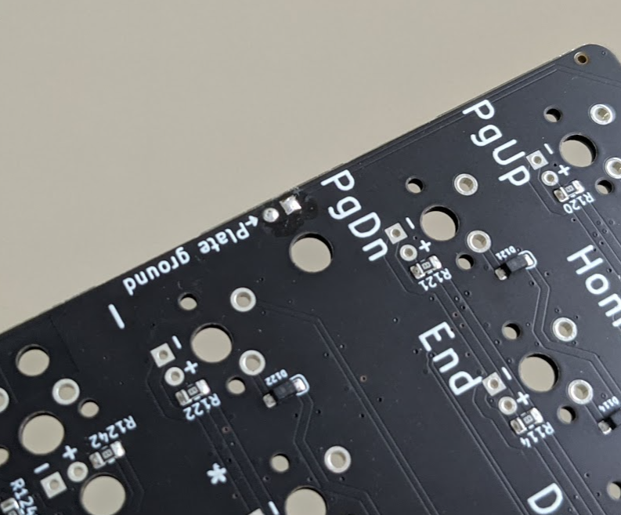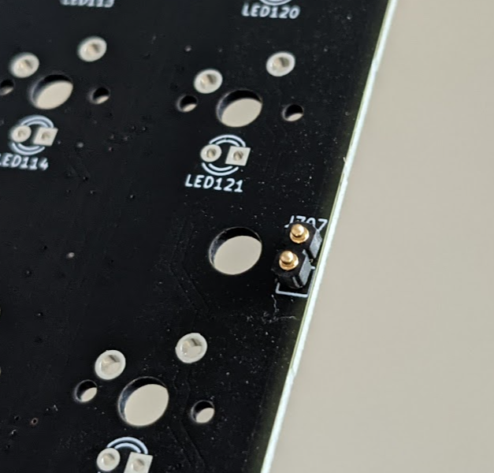 This is used to electrically ground the plate and the screws on the top of the case.

# **Part 4: installing stabilizers and switches**

**Deciding your layout**

Boston supports the following layouts:

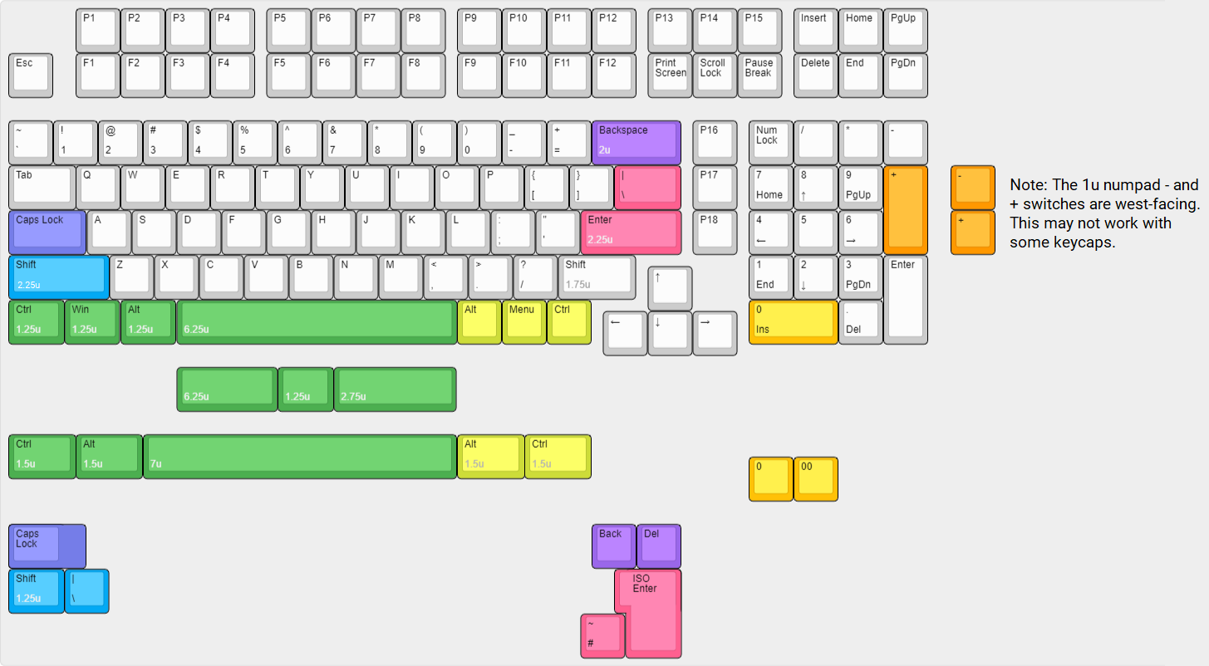

Decide what layout you want (for example, do you want ANSI Enter, or ISO Enter?), and determine where you’ll need to install stabilizers. Any keys 2 units wide or longer (for example, a standard backspace key) will need stabilizers. Also, make sure you have the keycaps for the layout you want.

**Modding switches and stabilizers**

If you want to mod or tune your switches or stabilizers (e.g. lubing them, or changing the springs in them), do so before installing them. It is much harder to make any changes after they’re installed. Stabilizers cannot be installed or removed after switches are soldered in, without desoldering most or all of your switches.  
 **Installing the stabilizers**

Boston takes PCB-mount stabilizers, either screw-in or clip in style. These are available from several manufacturers (e.g. GMK, Cherry, C3, Durock, Zeal, and others make PCB mount-stabilizers).

Install all the stabilizers according to the instructions from their manufacturer.

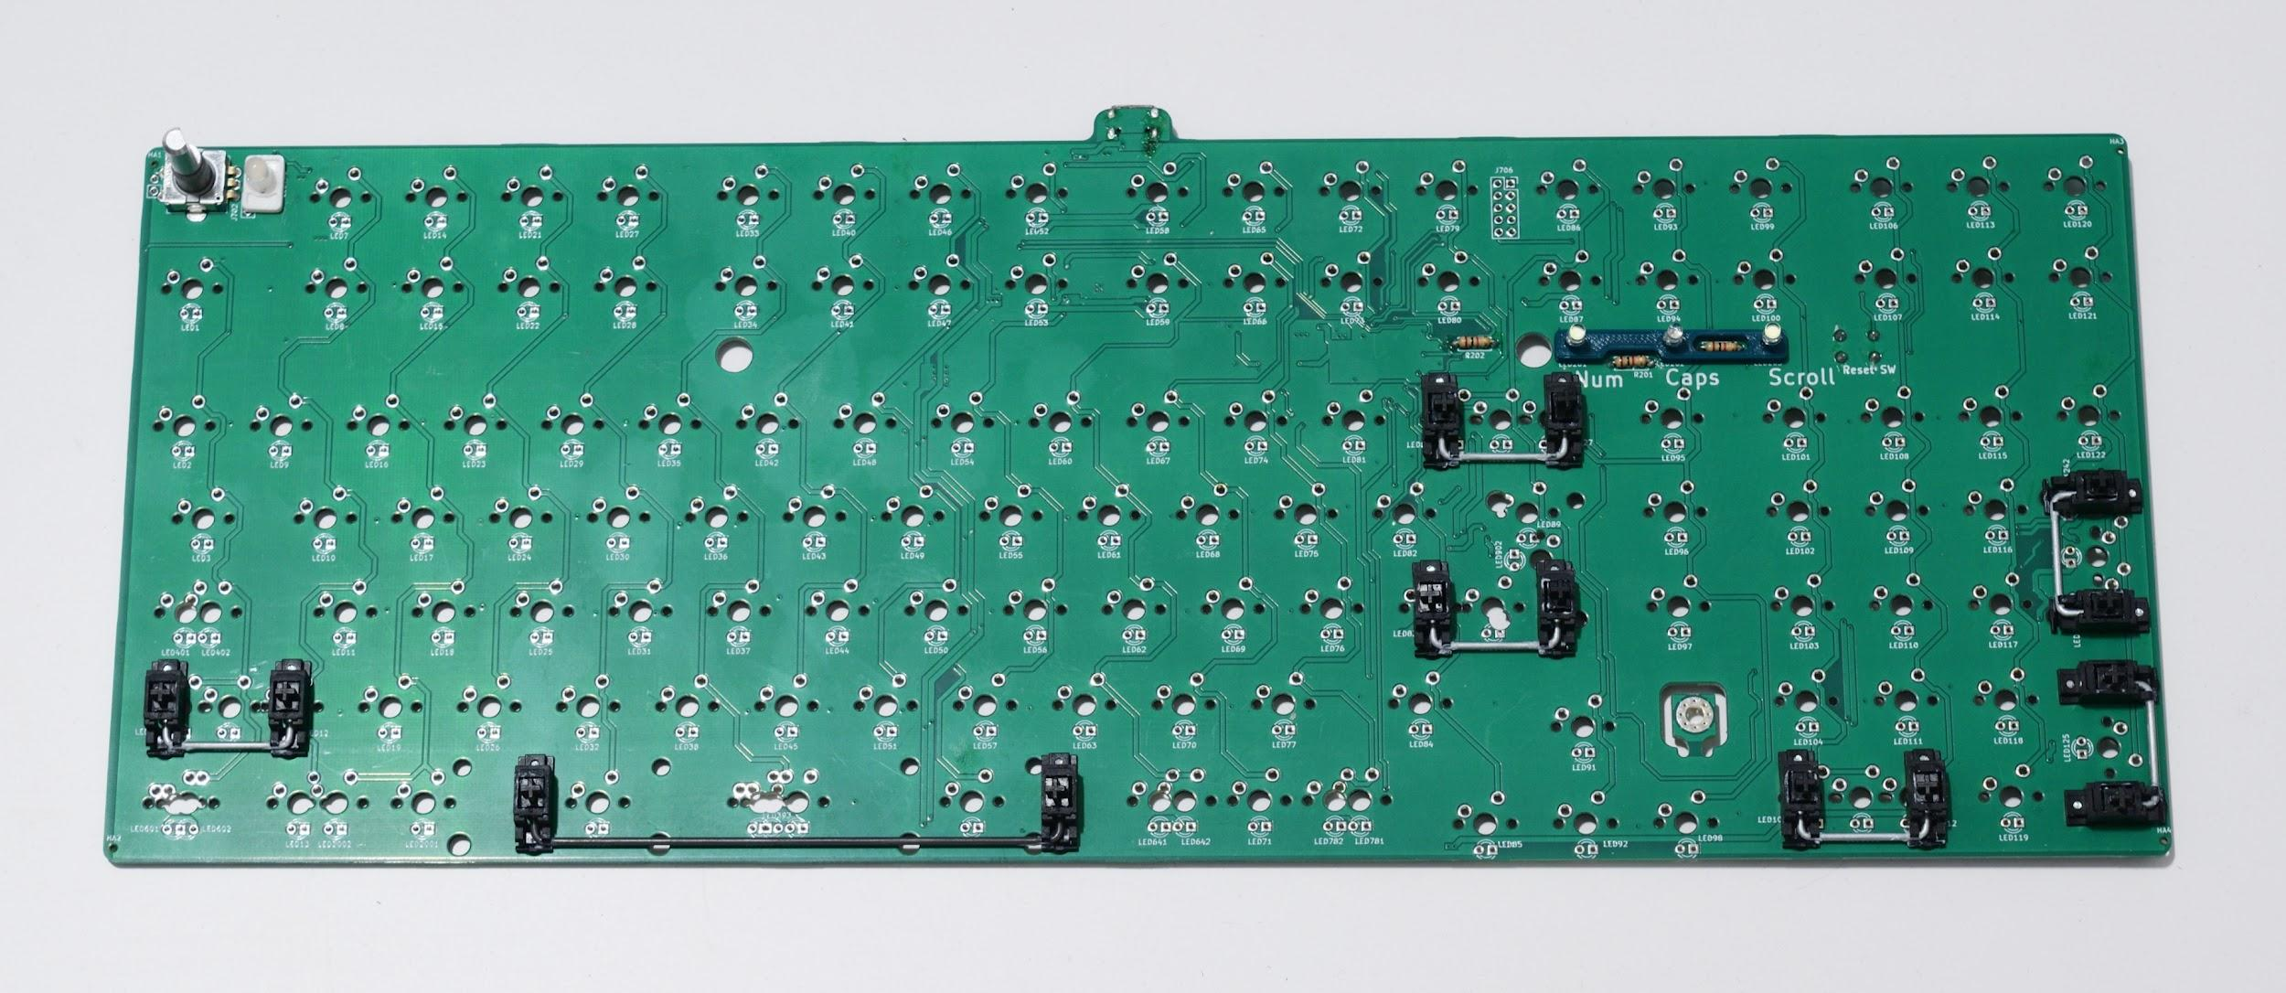  
It’s strongly recommended to test your stabilizers before proceeding, as any fixes to your stabilizers after soldering the switches will likely require desoldering all the switches and removing the plate from the PCB.

To do this, take the plate, a switch, and the appropriate keycap for the stabilizer you want to test, and install them over the PCB (without soldering the switch in). Make sure the key feels okay - that it’s not binding, or failing to go all the way to the bottom, or failing to return, for instance. Do this for all your stabilizers to make sure that they’ve been installed properly.   
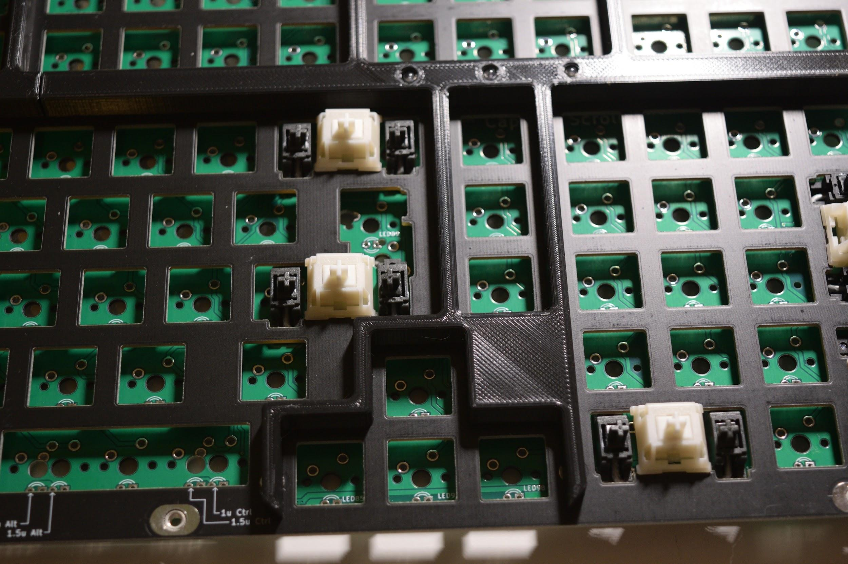  
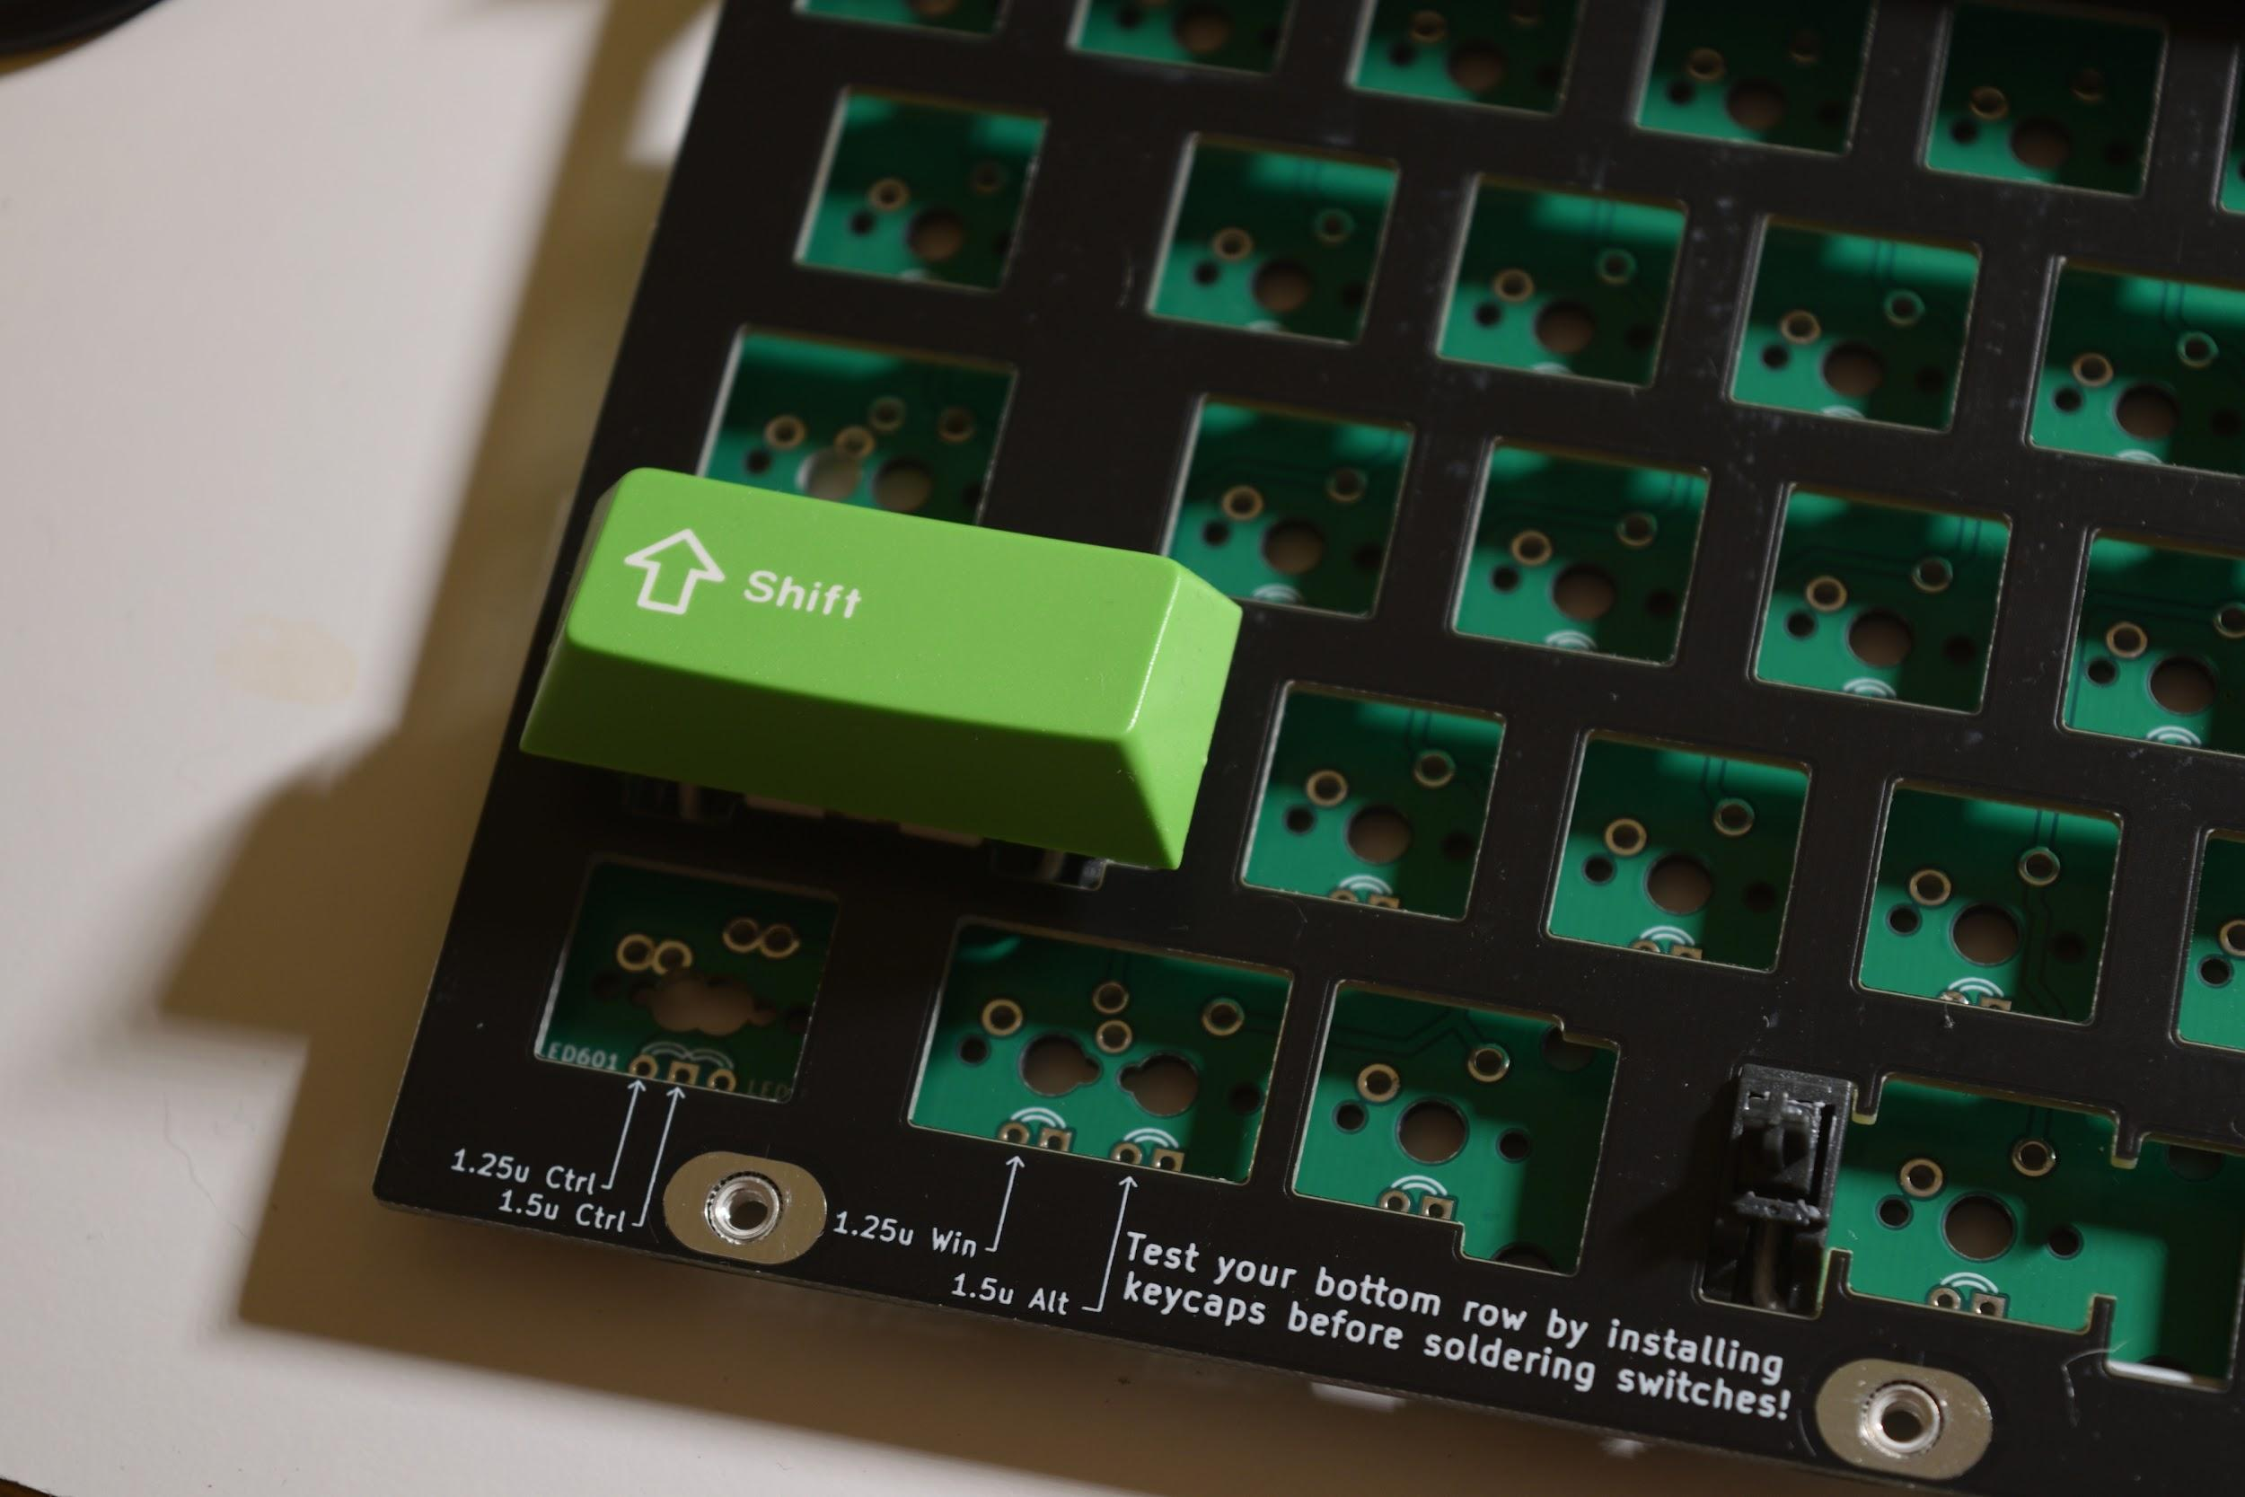

**Installing your bottom row**

We’ll start installing and soldering switches on the bottom row as this is the most likely place that mistakes are made.

As you can see from the “supported layouts”, Boston supports several different bottom row layouts, and it’s easy to accidentally put a switch in the wrong place.

Both the plate and PCB are marked with where to put the switches in for your desired bottom row positions. The arrows point at the center of the switch. Install switches into the desired positions on the bottom row. Make sure that the switches are fully seated into the plate.

After installing the switches into the plate, and before soldering the switches, install keycaps on your bottom row to ensure that everything is in the correct place. Make any fixes as necessary.   
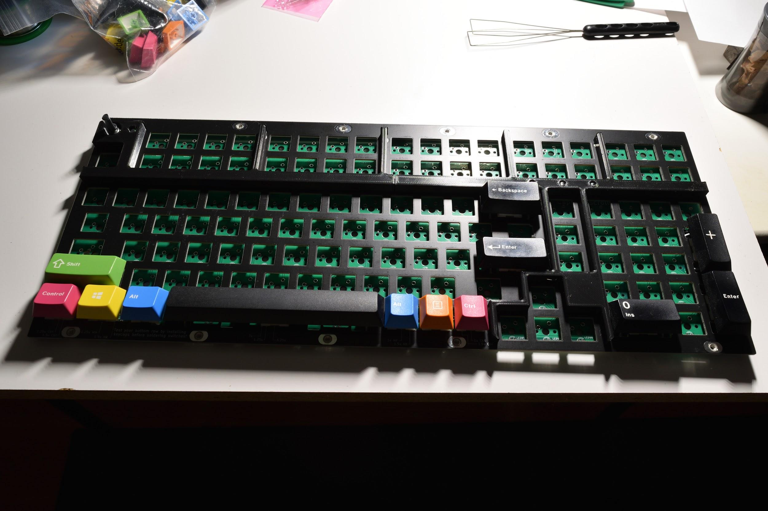

If everything looks correct, solder the switches in.

**Soldering the rest of the switches**

Install and solder in the rest of the switches.

# **Part 5 - Case Prep and Assembly**

**Installing the M3 hex nuts into the case**

Take the left and right case halves from earlier, and the M3 hex nuts. Push the hex nuts into the hex-shaped pockets on the bottom of the case. If it’s difficult to push them in, you can use an M3x6 screw to pull the nuts in. If the nuts fit in loosely and fall out easily, glue them in with super glue or hot glue.  
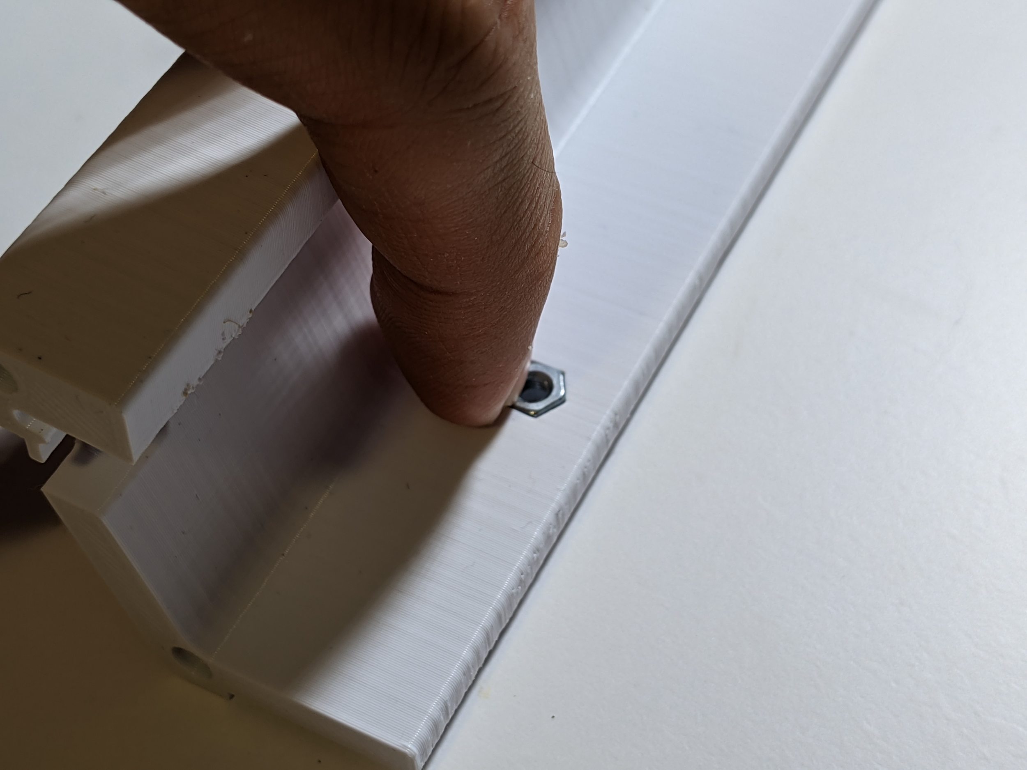

### 

**Installing the case halves**

Take the left and right case halves and slide them onto the plate, and screw them into the plate using M3x10 screws. **Do not tighten these down all the way - leave them about 1 turn loose**, as we need to align them later**.** For the right case half, you’ll have to spread the case apart slightly to get it past the arrow key cluster.

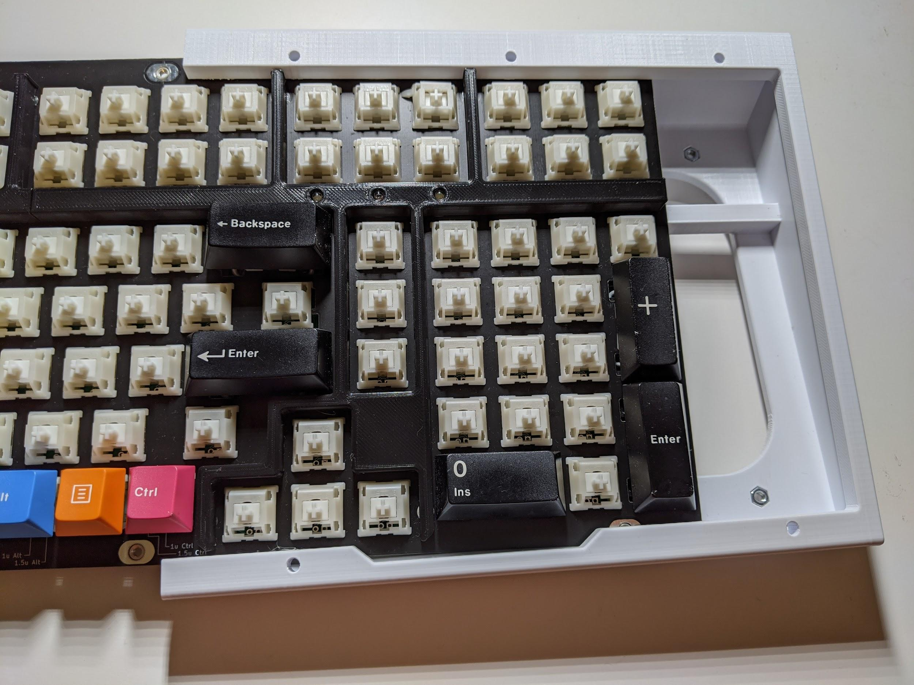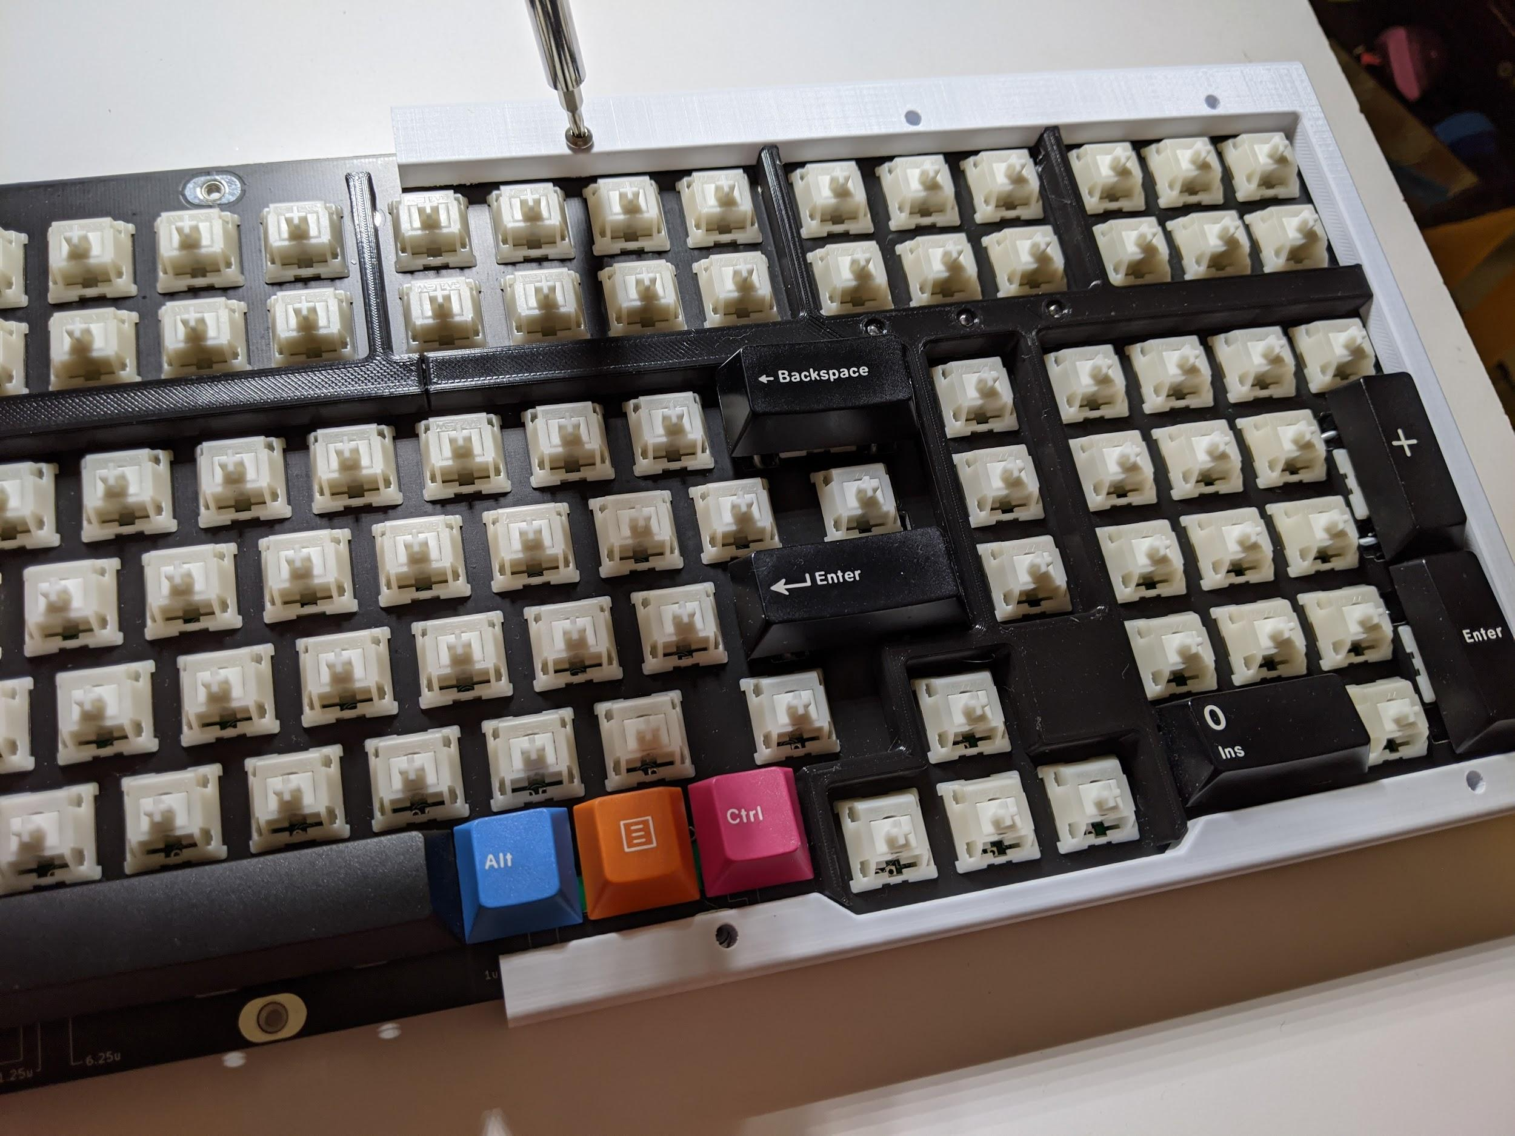

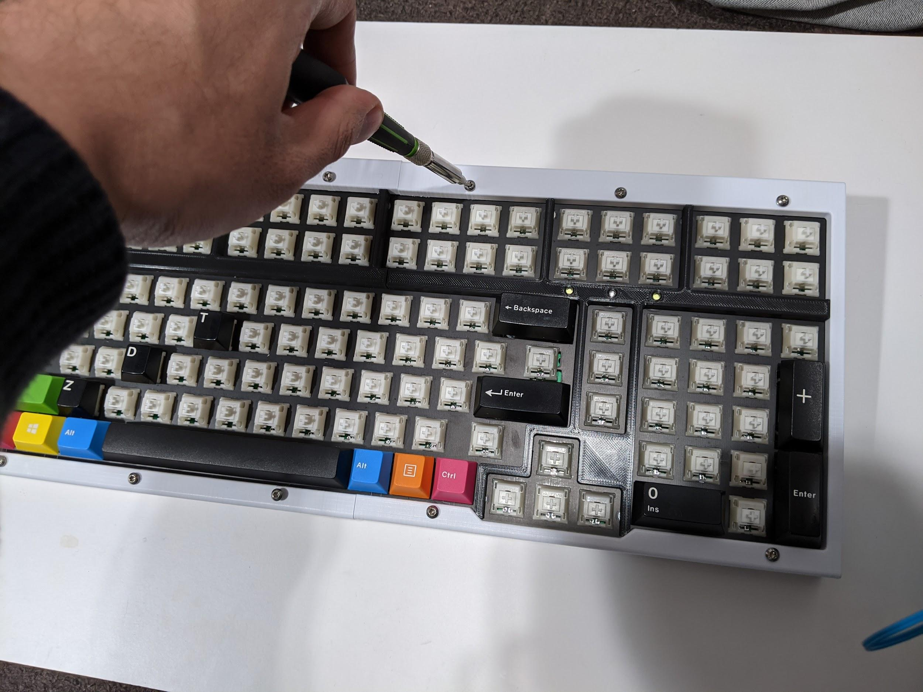

**Installing the bottom panel and the rubber feet**

Flip everything over, and place the bottom panel in the orientation shown (if you get it backwards, the reset switch will not be accessible). Install M3x6 screws in the middle 8 holes. Avoid pushing down on the screwdriver as this can cause the hex nut on the other side to push out and fall out (and you’ll have to take the case back apart to retrieve it and reinstall it). Again, don’t tighten these in all the way, but leave them about a turn loose.

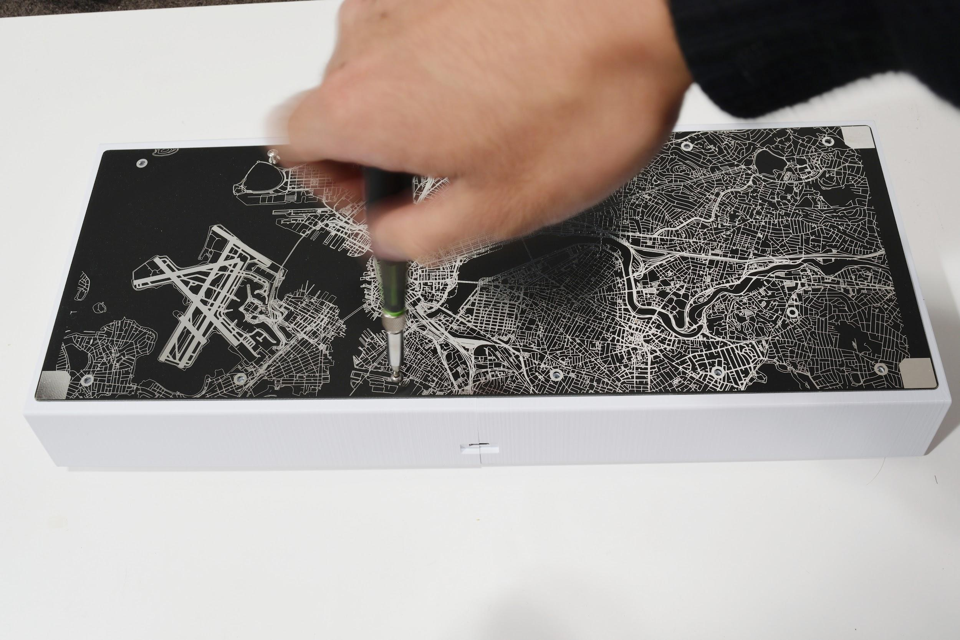

Take the FR4 rubber feet holders and install them on the ends using M3x10 screws. Again, avoid pushing down on the screwdriver. Tighten these screws in all the way.

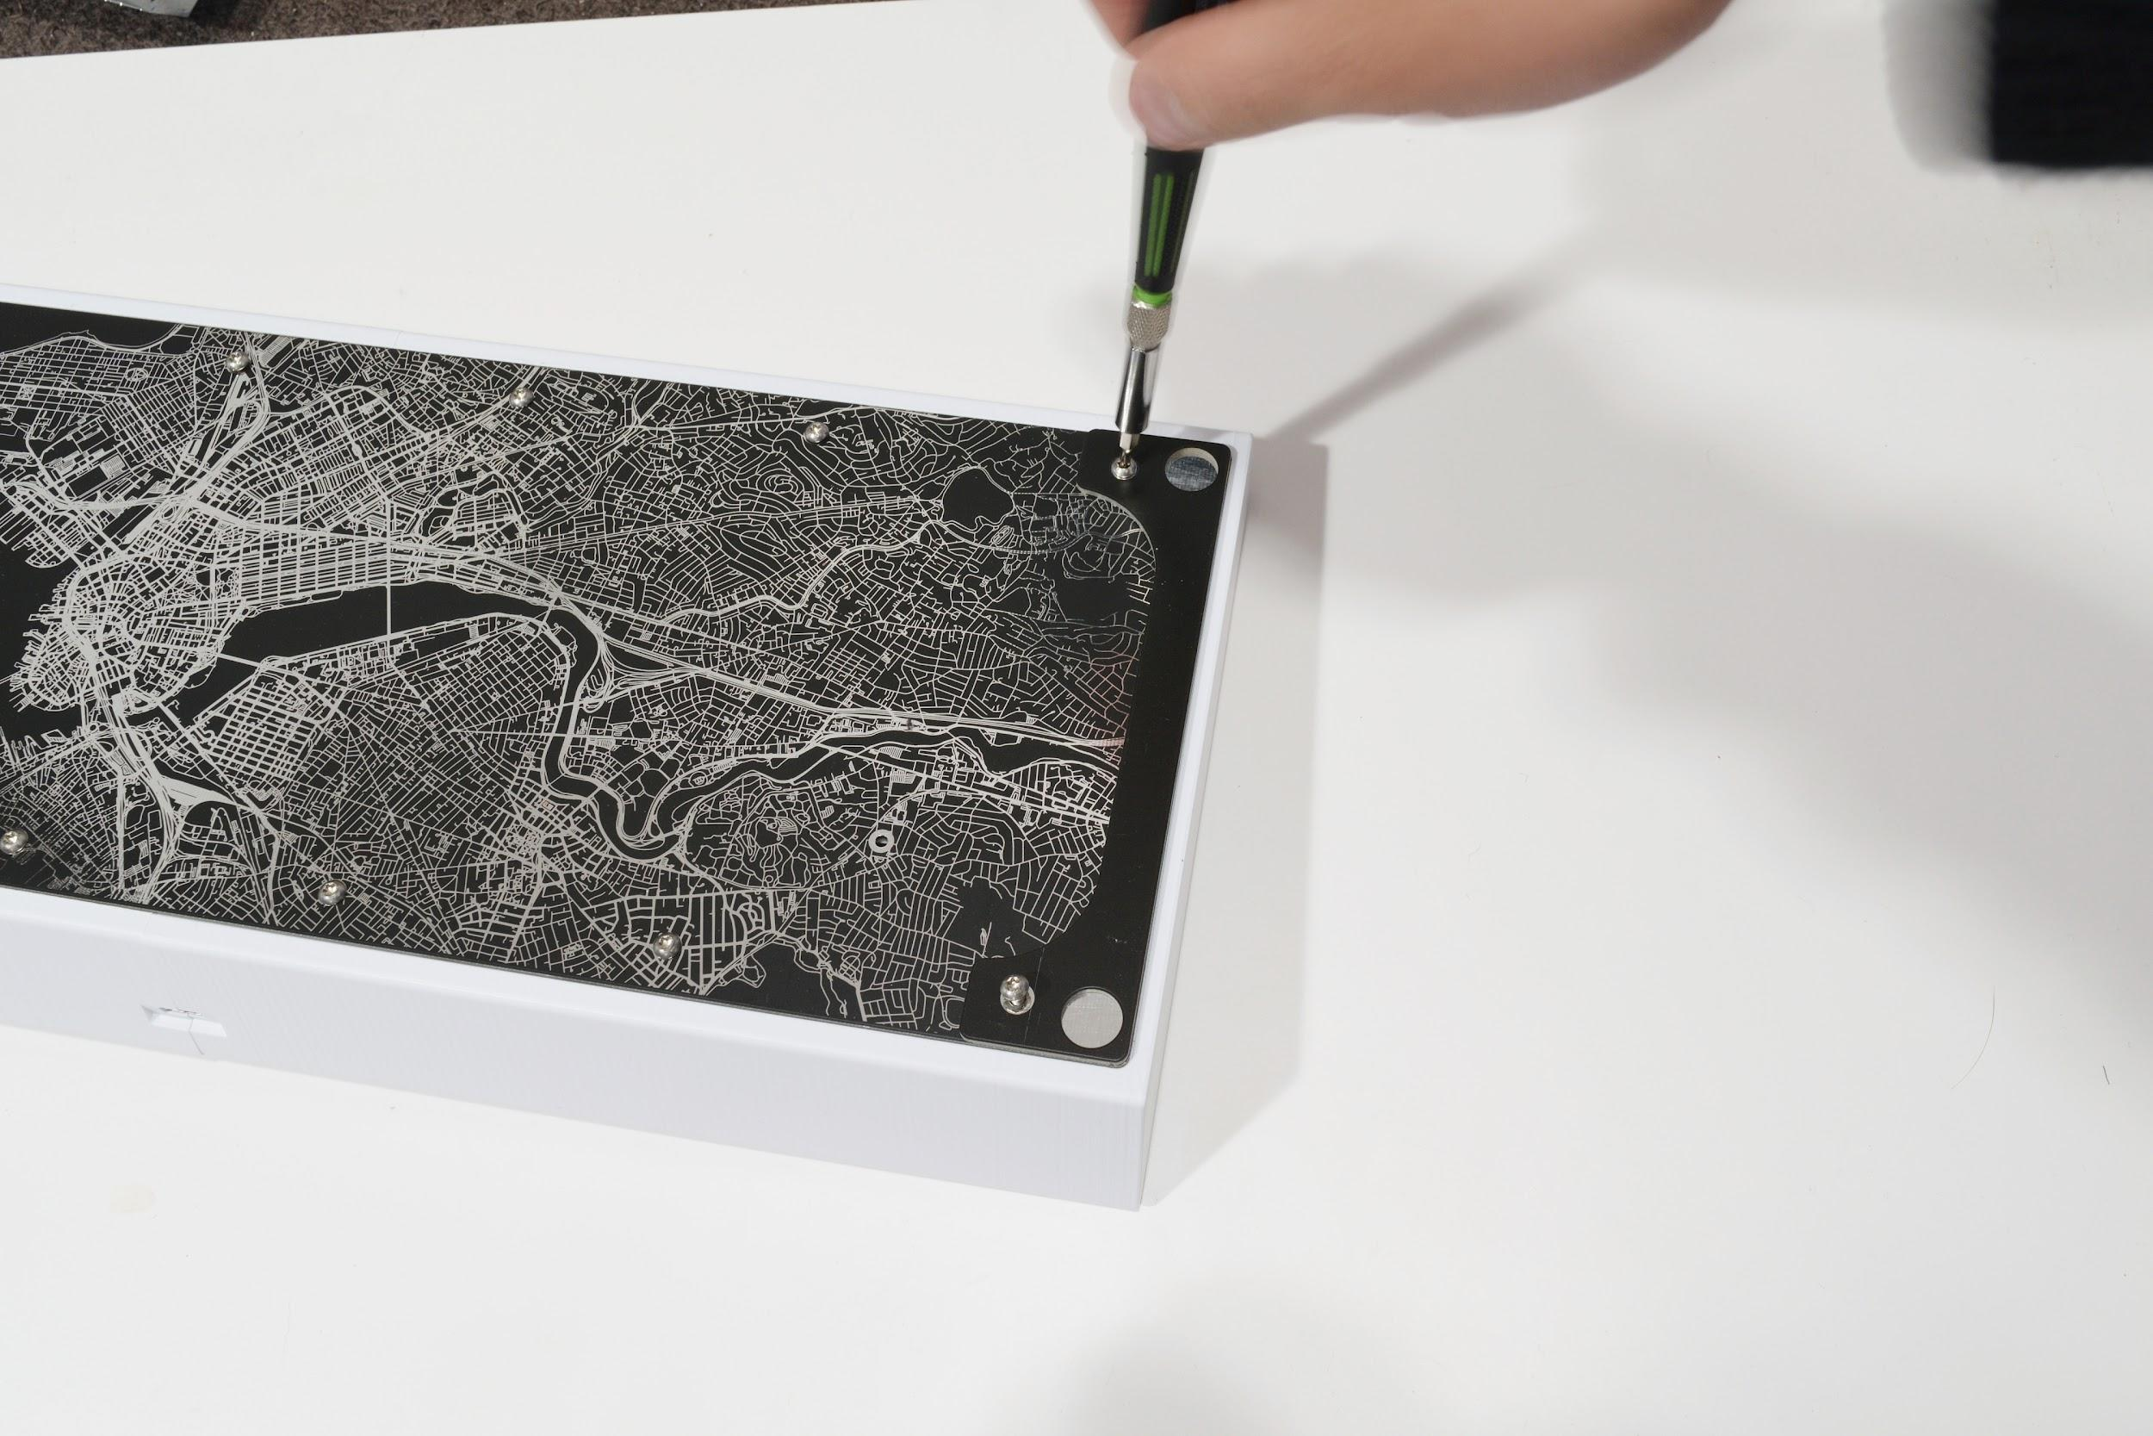

Once the rubber feet holders are installed, peel the rubber feet off from the backing sheet and stick them on the four corners.

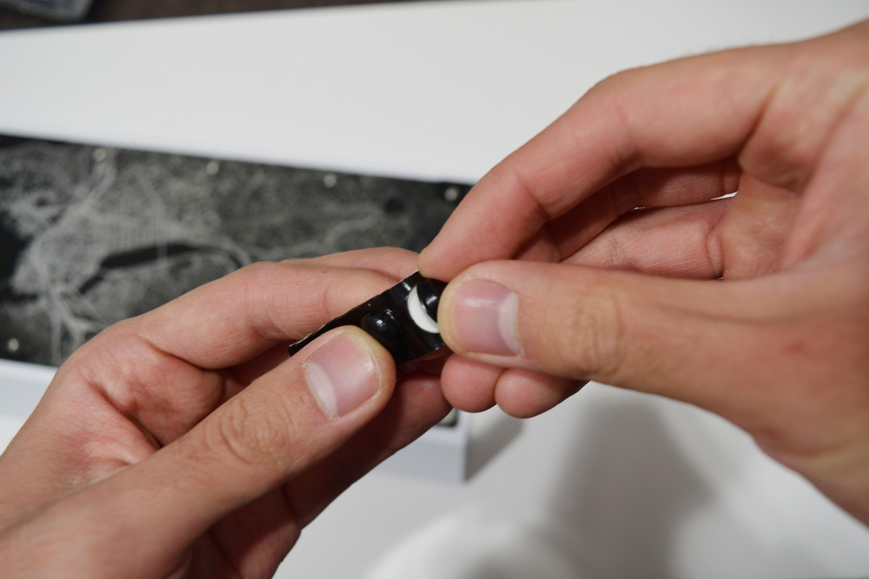

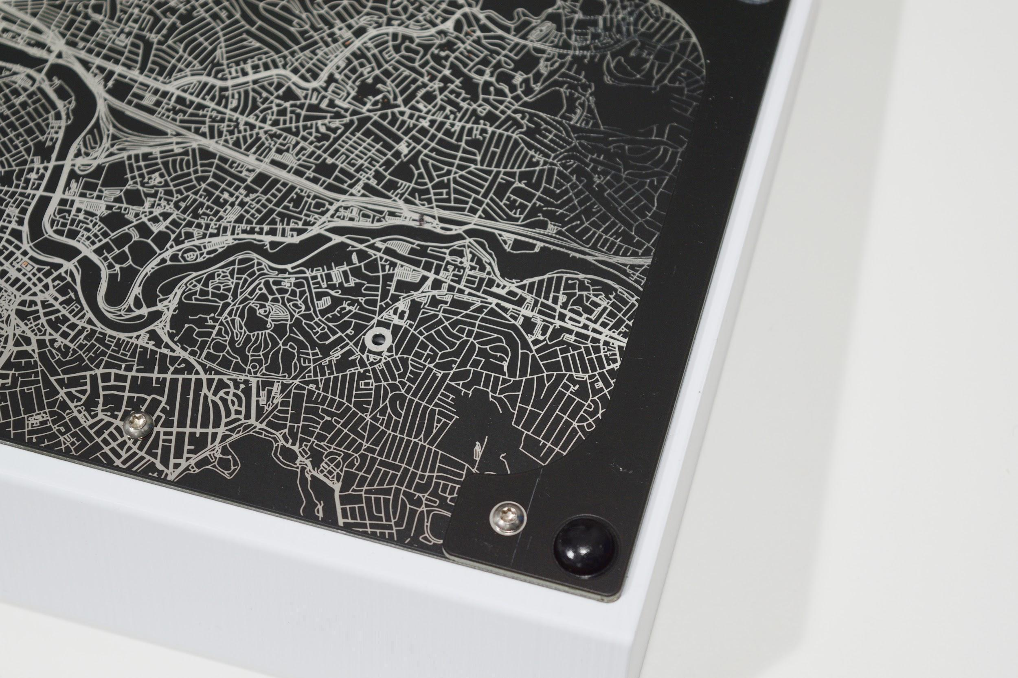

**Leveling the keyboard**

Next, take the keyboard and place it right-side up over a flat, level surface. Take your palm or forearm, and push the keyboard down against your flat, level surface, and tighten all the exterior case screws. This is to make sure the case and feet are flat and do not wobble.

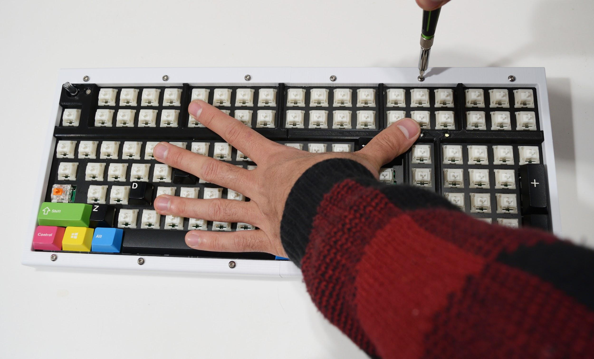

Once this is done, press down on the corners of the keyboard and make sure the keyboard doesn’t wobble or see-saw. If it still does, make adjustments as necessary. There may be a slight misalignment between the left and right case halves after this adjustment - this is normal, as unfortunately 3D printing is a relatively imprecise process. If there is unresolvable wobble or misalignment, you may need to adjust the frame alignment on your 3D printer and reprint the parts.  
  
After all this, install the knob and keycaps. Plug the keyboard into a computer and check that it works (it may take a couple of seconds for the keyboard to initialize). You’re done!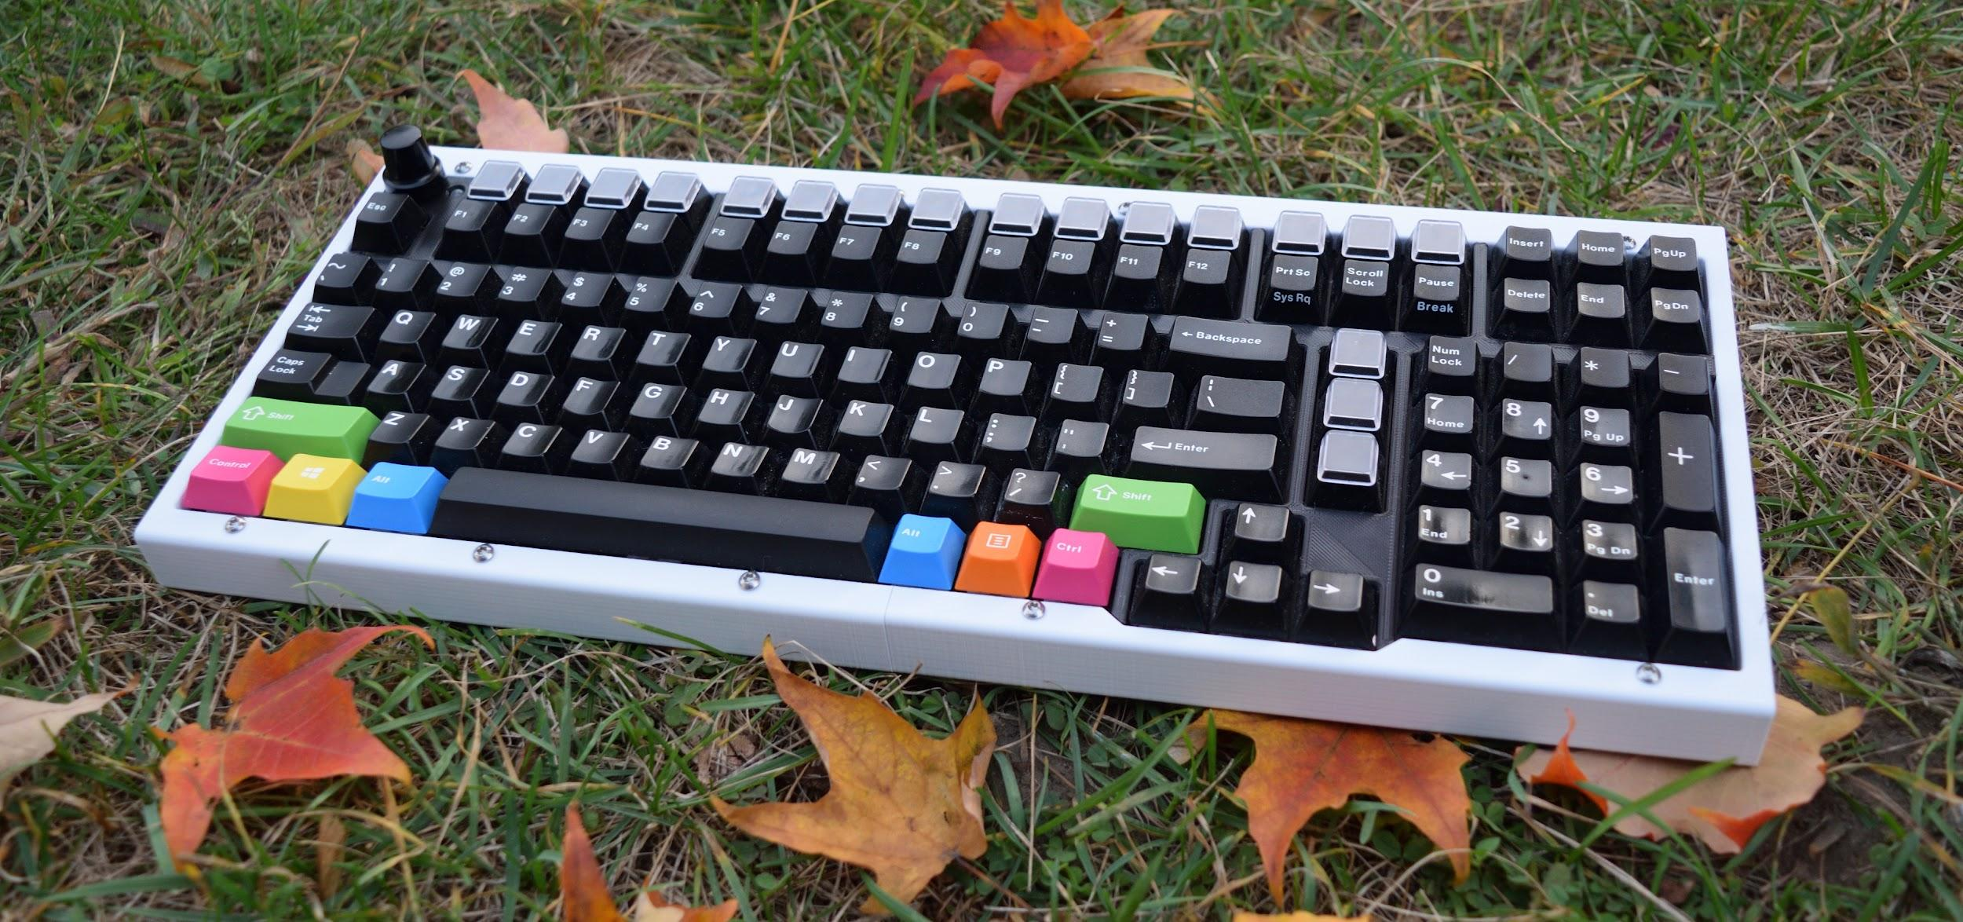

# **Part 6: Flashing Firmware**

Your keyboard comes with a default keymap and firmware installed. However, if you wish to flash a different firmware, please follow the following steps. You’ll also need a second keyboard for the flashing process.

1. Before flashing, you need to have the .bin file for your firmware. This can be:

* The default firmware, available on Github [here](https://github.com/bluepylons/Boston/blob/master/Boston - Current design/boston_default.bin). The key assignments in the Default Keymap are in the Appendix.
* The Vial firmware is available on Github [here.](https://github.com/bluepylons/Boston/blob/master/Boston - Current design/Firmware - Vial/boston_vial.bin) [Vial](https://get.vial.today/) is an open-source alternative to VIA, and allows you to remap keys without reflashing your keyboard. Instructions on how to use Vial are [here](https://get.vial.today/getting-started/first-use.html) .
* The output from QMK after you compile all the files, if you’re manually compiling QMK. To edit the current firmware files for Boston ([available](https://github.com/qmk/qmk_firmware/tree/master/keyboards/boston) on QMK’s Github) , you will need to set up a QMK build environment as according to the [instructions](https://beta.docs.qmk.fm/tutorial/newbs) on QMK’s website.

1. Plug your keyboard in. Insert an unbent paperclip or a small screwdriver through the hole on the bottom to press the reset switch. If you’re using a V0.6 or later PCB, you need to hold down the reset button for at least two seconds for it to enter the bootloader.

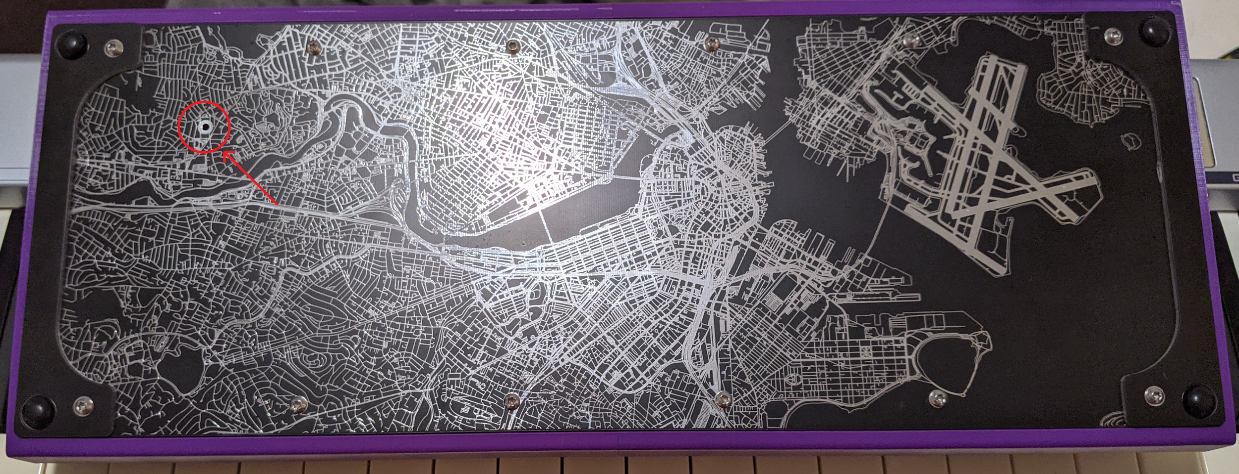

1. You’ll need to install drivers to communicate with the keyboard’s microcontroller properly. This can be done with a tool called [Zadig](https://zadig.akeo.ie/) on Windows.
2. Open Zadig:

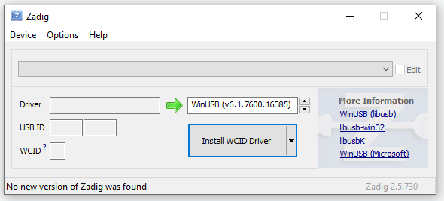

* 1. Select “List All Devices” in the Options Menu

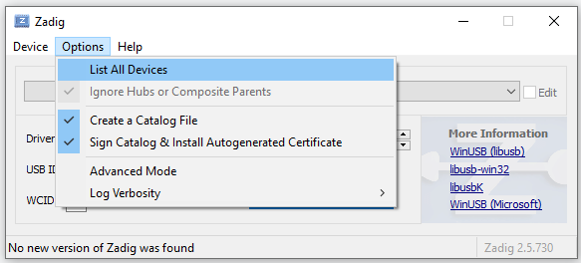

* 1. Select “STM32 Bootloader” in the dropdown menu:

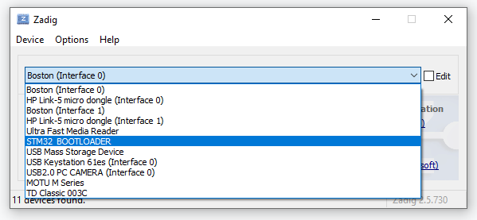

* 1. Select WinUSB here:

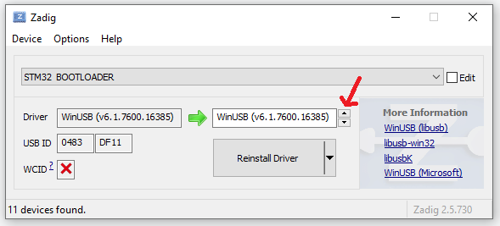

* 1. Click the Replace Driver button.

1. Download [QMK Toolbox](https://github.com/qmk/qmk_toolbox/releases).
2. Open QMK Toolbox. “STM32 DFU device connected” should appear in yellow. If that text isn’t there, press the reset switch on your keyboard according to the instruction earlier in 2)

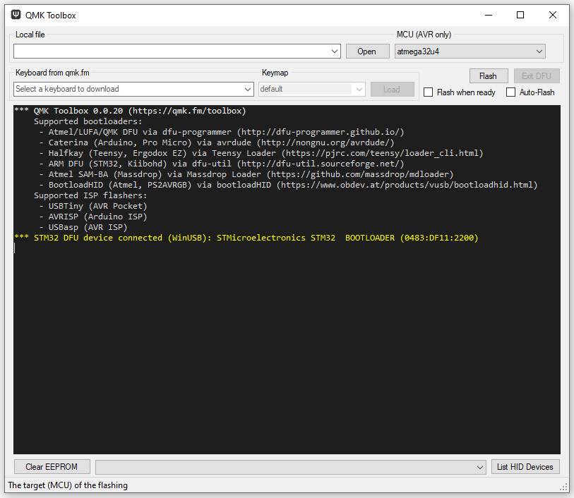

* 1. Press “Open” and navigate to the location of your .bin file.

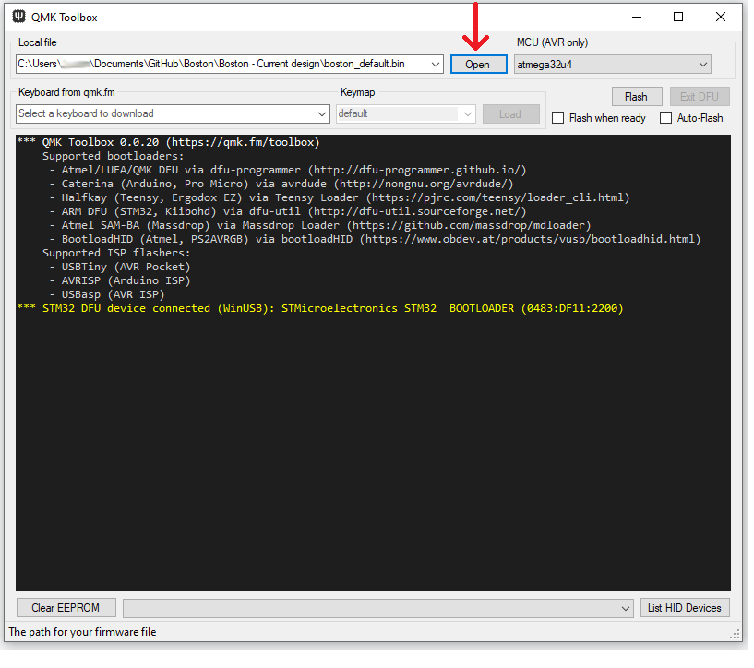

* 1. Press the Flash button. Do not disconnect the keyboard until it is done flashing, or you may permanently brick your keyboard.

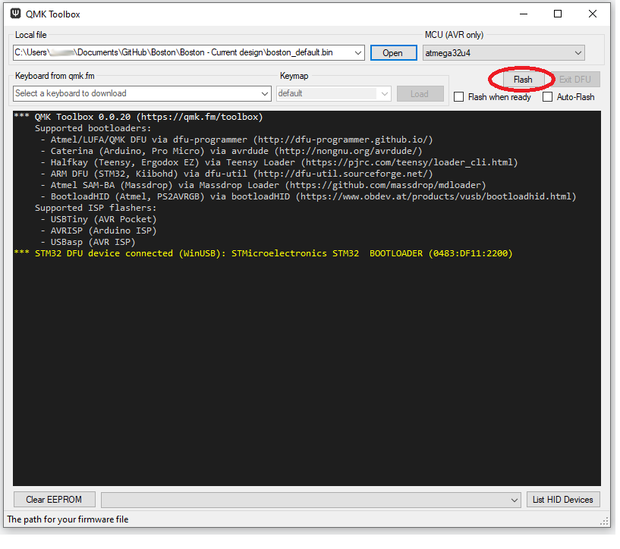

Once your flash is complete, your keyboard should be ready for use!

# **Appendix:**

A - Default firmware key assignments:

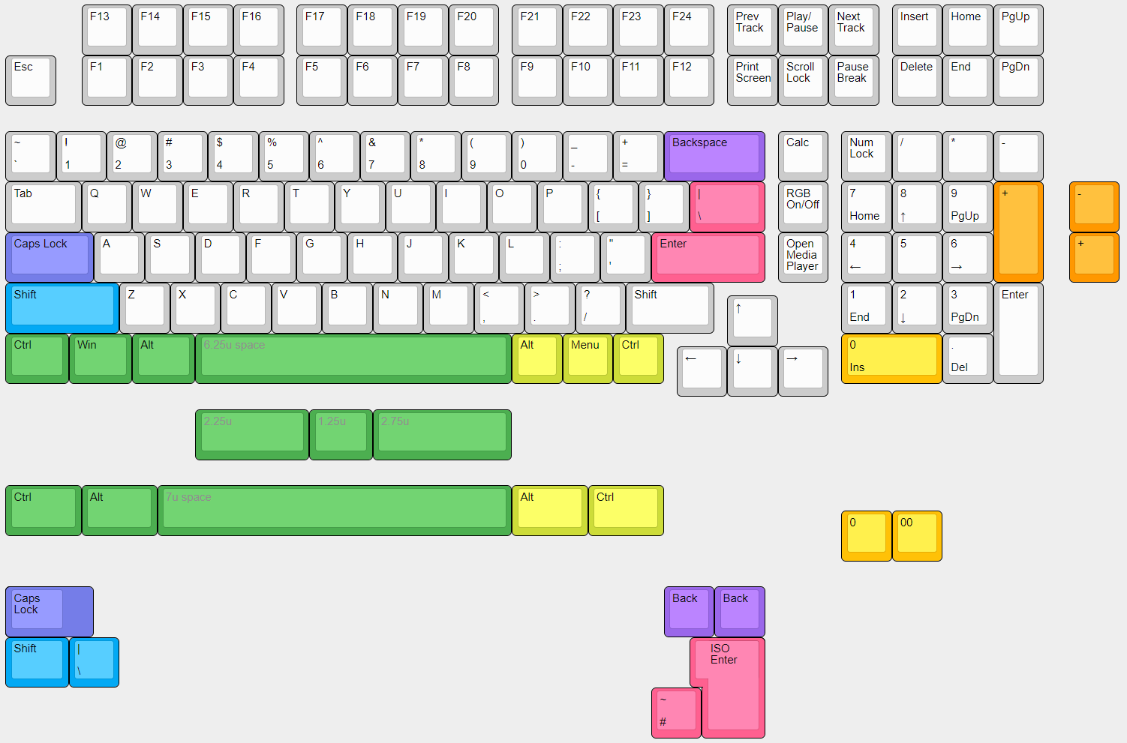

The knob is set for volume. Press the knob for mute.